**Philippine Copyright 2022**

by the Author

and the

College of Engineering

Polytechnic University of the Philippines

All rights reserved. Portions of this manuscript may be reproduced with proper referencing and due acknowledgment of the author

**EFFECT OF AUTOMATIC DISINFECTION BOX USING   
ULTRA VIOLET LIGHT ON MICROBIAL GROWTH   
OF MICROORGANISMS**

A Thesis  
Presented to the Faculty of Computer Engineering  
Polytechnic University of the Philippines  
Sta.Mesa, Manila

In Partial Fulfilment of the Requirements for the Degree  
Bachelor of Science in Computer Engineering

by

**John Christopher B. Bagas**

**Charles Adriane S. Guerrero**

**Marcus M. Saralde**

September 2022

**CERTIFICATION**

This is to certify that we have supervised the preparation of and read the design project paper prepared and submitted by **John Christopher B. Bagas, Charles Adriane S. Guerrero, Marcus M. Saralde** entitled **EFFECT OF AUTOMATIC DISINFECTION BOX USING ULTRA VIOLET LIGHT ON MICROBIAL GROWTH OF MICROORGANISMS** in partial fulfillment of the requirements for the degree, Bachelor of Science in Computer Engineering has been examined and recommended for Oral Examination.

**Engr. Pedrito M. Tenerife Jr. Engr. Jonathan C. Manarang**

Thesis Adviser Thesis Adviser

**APPROVAL**

As members of the Panel, we certify that we have examined this paper and hereby recommend that it can be accepted as fulfilment of the requirement for the degree in Bachelor of Science in Computer Engineering.

**Engr. Rolito L. Mahaguay**

Lead Panel

**Engr. Christian Bart F. Sadiwa Engr. Mark Jeanbert C. Nabong**

Panel Member Panel Member

This design project paper is hereby approved and accepted by the College of Engineering as fulfillment of the requirement for the degree in Bachelor of Science in Computer Engineering.

|  |  |
| --- | --- |
| **Engr. Julius S. Cansino** | **Dr. Remedios G. Ado** |
| Chairperson, Computer Engineering Department | Dean, College of Engineering |

**ACKNOWLEDGEMENTS**

Double-space the text that begins three single spacesfrom the heading.

**CERTIFICATION OF ORIGINALITY**

This is to certify that the research work presented in this thesis, *EFFECT OF AUTOMATIC DISINFECTION BOX USING ULTRA VIOLET LIGHT ON MICROBIAL GROWTH OF MICROORGANISMS* for the degree Bachelor of Science in Computer Engineering at the Polytechnic University of the Philippines embodies the result of original and scholarly work carried out by the undersigned. This dissertation does not contain words or ideas taken from published sources or written works that have been accepted as basis for the award of a degree from any other higher education institution, except where proper referencing and acknowledgment were made.

**BAGAS, JOHN CHRISTOPHER B.**

Researcher

**GUERRERO, CHARLES ADRIANE S.**

Researcher

**SARALDE, MARCUS M.**

Researcher

**ABSTRACT**

|  |  |
| --- | --- |
| Title | : Effect of Automatic Disinfection Box using Ultra  Violet on Microbial Growth of Microorganisms |
| Name of Researchers | : John Christopher B. Bagas, Charles Adriane S.  Guerrero, Marcus M. Saralde |
| Degree | : Bachelor of Science in Computer Engineering |
| Institution | : Polytechnic University of the Philippines |
| Year | : 2022 |
| Advisers | : Engr. Jonathan C. Manarang, Engr. Pedrito M.  Tenerife Jr. |

Researchers aim to determine the effectiveness of ultra violet lights in disinfecting using an automatic disinfection box. Researchers ought to find the significant difference for disinfecting between UV-based disinfectant and alcohol-based disinfectant, the significant effect of UV intensity, and the difference among the different duration in terms of its effectiveness. Researchers conduct streak plate and spread analysis on four similar pens under normal condition. Effectiveness of UV based and Alcohol based disinfectant were measured based on number of colonies in different treatments. Different treatments were replicated thrice and were compared to a baseline treatment wherein the agar plate was not exposed to UV or Alcohol. Gathered data are analyze using Two-sample & one-sample Wilcoxon test and Kruskal-Walis test. Four-point Likert scale are use to describe the device in terms of necessity, quality, price-quality ratio and approval. Results revealed that the baseline treatment was relatively higher compared to Alcohol based and UV based treatments. This suggests that Alcohol based and UV based disinfectant were more effective in terms of bacterial inhibition. Study shows that there is enough evidence to conclude that UV and Alcohol based disinfectant exhibit no significant difference when it comes to their effectiveness, UV intensity has a significant effect in terms of effectiveness, the different durations (10, 20, 30 seconds) of UV exposure show no significant difference in terms of effectiveness. Responses shows that the automatic disinfection meets current pandemic situation extremely well, has a very high quality, in terms of price has an above average value for money and the respondents are very satisfied using the device. The researchers recommend develop a real-time UVC dosage monitor module that shows the current UVC dosage of the device producing and a proper item counter.

Keywords: Automatic Disinfection, COVID19, Ultra Violet, Microbial Growth, Microorganisms

**TABLE OF CONTENTS**

|  |  |
| --- | --- |
|  | Page |
| **Title Page** | i |
| **Certification-and-Approval Sheet** | ii |
| **Acknowledgements** | iii |
| **Certificate of Originality** | iv |
| **Abstract** | v |
| **Table of Contents** | vii |
| **List of Tables** | x |
| **List of Figures** | xi |
| 1 **The Problem and Its Setting** |  |
| Introduction | 1 |
| Theoretical Framework | 2 |
| Conceptual Framework | 4 |
| Statement of the Problem | 4 |
| Hypothesis | 5 |
| Scope and Limitations of the Study | 5 |
| Significance of the Study | 6 |
| Definition of Terms | 8 |
| 2 **Review of Literature and Studies** |  |
| Ultraviolet Disinfection | 10 |
| Time to Inactivate Microorganisms | 21 |
| UVC Direct Exposure | 21 |
| UV-C Penetrable Plastic & Materials | 22 |
| UVC Exposure Risks | 22 |
| Ultraviolet Disinfection Machines | 25 |
| Streak Plate Method | 28 |
| Spread Plated Method | 28 |
| Kirby Bauer Disc Diffusion Method for Antibiotic Susceptibility  Testing | 30 |
| Synthesis of Reviewed Literature and Studies | 30 |
| 3 **Methodology** |  |
| Research Design | 31 |
| Description of Respondents | 31 |
| Flowchart of Research Design | 33 |
| Description of Research Instrument Used | 34 |
| Statistical Treatment | 34 |
| Material Requirement | 35 |
| Field Experiment | 35 |
| 4 **Results and Discussion** |  |
| Components of the Proposed System | 42 |
| Device Implementation | 42 |
| Disinfection Distance | 44 |
| Materials and Specifications | 45 |
| Detailed Procedure of Device Implementation | 46 |
| Block Diagram | 52 |
| Flowchart | 53 |
| Component Analysis | 54 |
| Schematic Diagram | 56 |
| Fabrication of the Device | 57 |
| Field Experiment | 58 |
| Survey Results and Discussion | 60 |
| 5 **Summary of Findings, Conclusions, and Recommendations** |  |
| Summary of Findings | 62 |
| Conclusions | 67 |
| Recommendations | 68 |
| **References** | 69 |
| **Curriculum Vitae** |  |
| **Appendices** |  |
| Appendix 1: Letter of Intent | 81 |
| Appendix 2: Summary of Comments | 83 |
| Appendix 3: Letter of Permission to conduct field experiment | 85 |
| Appendix 4: Initial Draft | 87 |
| Appendix 5: Survey Questionnaire | 89 |
| Appendix 6: Source Code | 92 |
| Appendix 7: Bills of Materials | 96 |
| Appendix 8: Letter of Permission to rename the study | 98 |
| Appendix 9: Certificate of Analysis | 100 |
| Appendix 10: Certification of Statistical Treatment | 102 |

**List of Tables**

|  |  |  |
| --- | --- | --- |
| Number | Title | Page |
| 1 | **Experiment Analysis** | 58 |
| 2 | **Survey Response Mean** | 60 |
| 3 | **4-Point Likert Scale** | 64 |
| 4 | **Response Mean** | 65 |

**List of Figures**

|  |  |  |
| --- | --- | --- |
| Number | Title | Page |
| 1 | **Conceptual Framework** | 4 |
| 2 | **Random respondent inspecting the device** | 33 |
| 3 | **Research Design Flowchart** | 34 |
| 4 | **Swabbing of Pen 1** | 37 |
| 5 | **Disk Diffusion on Plate B** | 37 |
| 6 | **Alcohol Punchlets on Plate B** | 38 |
| 7 | **UVC Exposure on Pen 2** | 38 |
| 8 | **Swabbing of Pen 2** | 39 |
| 9 | **UVC Exposure of Pen 3** | 39 |
| 10 | **Swabbing of Pen 3** | 40 |
| 11 | **UVC Exposure of Pen 4** | 40 |
| 12 | **Swabbing of Pen 4** | 41 |
| 13 | **Front and Side View of the Device** | 43 |
| 14 | **3-Dimensional view of the Device** | 43 |
| 15 | **Beam Angle** | 45 |
| 16 | **Welding of Angle Bars** | 46 |
| 17 | **Rigid Frame** | 47 |
| 18 | **Rigid Frame Upside Down** | 47 |
| 19 | **Welding of Door Frames** | 48 |
| 20 | **Attaching of Door Frames** | 48 |
| 21 | **Steel Walls** | 49 |
| 22 | **Sanding of Rigid Frame** | 49 |
| 23 | **Applying Aerosol Paint** | 50 |
| 24 | **Mesh Panel** | 50 |
| 25 | **Fixed Mesh Panel** | 51 |
| 26 | **Applying Silicon** | 51 |
| 27 | **Automatic Disinfection Box** | 52 |
| 28 | **Circuit Block Diagram** | 52 |
| 29 | **Circuit Flowchart** | 53 |
| 30 | **Schematic Diagram** | 56 |
| 31 | **Soldering of Components** | 57 |
| 32 | **Two Sample Wilcoxon Test** | 62 |
| 33 | **One Sample Wilcoxon Test** | 62 |
| 34 | **Kruskal-Walis Test** | 63 |
| 35 | **Survey Response in terms of Necessity** | 65 |
| 36 | **Survey Response in terms of Quality** | 66 |
| 37 | **Survey Response in terms of Price-Quality** | 66 |
| 38 | **Survey Response in terms of Approval** | 67 |

**Chapter 1**

**THE PROBLEM AND ITS SETTING**

This chapter will discuss the general concepts of the study with the title “Effect of Automatic Disinfection Box using Ultra Violet on Microbial Growth of Microorganisms”. This includes the introduction, theoretical and conceptual frameworks, statement of the problem, scope and limitations, significance of the study and definition of terms.

**Introduction**

In December of 2019 in Wuhan, China, an outbreak occurred due to the spread of the Novel Coronavirus. The virus spread at rapid rate and infect many people. Causing a great number of hospitalizations and casualties. The virus spread through-out the globe and recognized as global pandemic affecting more than 220 countries (Worldometer, 2021).

According to Kodoth et. Al. (2020), the society need to be cautious of other dangerous microorganisms that spread illness in addition to viruses. Humans are constantly in contact with germs and bacteria. Many surfaces and objects we come in contact with every day are covered in microorganisms that are potentially harmful to normal people with normal immunity. When poor hygiene habit is practiced, microorganisms can be passed from person to person (Francisco, 2022). These could potentially cause sickness and may escalate to something serious.

The Coronavirus cause a significant impact on disinfectant industry. Sudden rise in demand for sanitizers and disinfectant as a preventive measure against the virus has change the dynamic of the market (Reports and Data, 2020). The disinfectant demand imposes a challenge and concern to supply chain.

According to NationalAcademies (2021), ultraviolet lights specifically UVC, have the trait to inactivate SARS-CoV-2 and shows effectivity against reducing germs and inhibits microbial growth (Francisco, 2022). Cognizant of the growing problem, the researchers develop and design an automatic disinfecting box with UVC lamps as treating agent to disinfect materials and objects.

**Theoretical Framework**

The COVID-19 or coronavirus disease 2019 caused a pandemic that affected large numbers of people worldwide. Kitagawa et al. (2020), suggests that proper disinfection of SARS-CoV-2 contaminated surfaces helps prevent the spread.

According Kitagawa et al. (2020), the efficiency 222-nm UVC irradiation technology on severe acute respiratory syndrome coronavirus 2 (SARS-CoV-2) in unoccupied and occupied spaces can be used.

According to an in vitro experiment of Kitagawa et al. (2020), the 222-nm UVC irradiation in contaminated SARS-CoV-2 have significant effect. 0.1 mW/cm2 concentration of SARS-CoV-2 have been investigated after irradiating with 222 nm between 10 and 300 seconds in 50% infectious dose of tissue culture (TCID50). Quantitative transcription polymerase chain reaction is used to measure SARS-CoV-2 RNA with the same conditions.

The study has shown that 88.5 to 99.7% of SARS-CoV-2 has reduced based on the TCID50 test and resulted in one and 3 mJ/cm2 of 222-nm UVC irradiation for between 10 and 30 seconds. The test has also shown that SARS-CoV-2 RNA copies does not change after 5-minute irradiation of UVC.

The 222-nm UVC lamps is relatively safe for human skin interaction according to Nozomi et al. (2020). The 222-nm UVC suggests disinfecting ability is comparable with the 254-nm UVC causing cyclobutane pyrimidine dimers (CPDs) that lacerates DNA by ultraviolet.

The study has shown that 99.7% are reduced in SARS-CoV-2 after 30 second exposure to three 0.1 mW/cm2 222 nm UVC light according to the TCID50 test. The SARS-CoV-2 number does not change after the irradiation of ultraviolet.

According to Aisha et. Al (2018), Ultraviolet light destroys harmful microbes such as bacteria, yeast, molds, viruses and algae, and ultraviolet radiation is less toxic to cave dwellers such as birds, reptiles and visitors. So ultraviolet radiation can be a way to control microorganisms or reduce their numbers. Microorganisms isolated from selected Malaysian caves are gathered and studied to control and eliminate them After 5 minutes exposure, 254nm UV-C effectively eliminated colonies of Pseudomonas aeruginosa and Stenotrophomonas sp. But P. guilliermondii and R. dairenensis were eliminated to the zero after 30 minutes of treatment, but C. Liquefaciens needed 60 minutes to be treated. Synechochococcus sp and Micractinium sp. fell to zero after exposure to 240 of UV-C.

**Conceptual Framework**

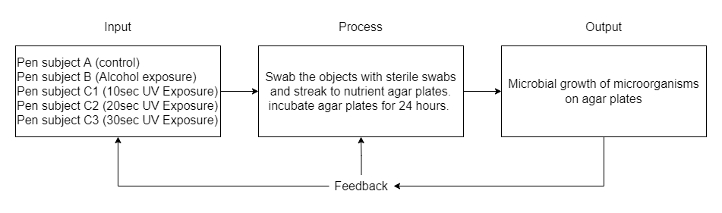

Figure 1. Conceptual Framework

**Statement of the Problem**

This study aims to determine the effectiveness of ultra violet lights in disinfecting using an automatic disinfection box. Specifically, the study sought to find the answers to the following questions:

1. What is the significant effect of ultraviolet intensity to be use in terms of its effectiveness?
2. What is the significant difference among the different duration in terms of its effectiveness?
   1. 10 seconds
   2. 20 seconds
   3. 30 seconds
3. How does the automatic disinfection box be described in terms of?
   1. Necessity
   2. Quality
   3. Price-quality ratio
   4. Approval
4. Is there a significant difference between ultraviolet-based disinfectant and alcohol-based disinfectant in terms of their effectiveness?

**Hypothesis**

The researchers lead up to the following hypothesis. There is no significant difference between ultraviolet-based disinfectant and alcohol-based disinfectant in terms of their effectiveness. There is no significant effect of ultraviolet intensity to be use in terms of its effectiveness. There is no significant difference among the duration of 10 seconds, 20 seconds, and 30 seconds in terms of its effectiveness. The automatic disinfection box does not meet current pandemic situation extremely well. The automatic disinfection box has a very low quality. The automatic disinfection box in terms of price has a poor value for money. The respondents are very dissatisfied using the automatic disinfection box.

**Scope and Limitations of the Study**

The device will have a dimension of 72cm in height, 84cm in length, and 54cm in width. The entrance clearance of the frame will have a dimension of 68cm in height and 78cm in width. The device will have a PIR sensor to detect if and object is ready inside the device.

The study will be limited to the comparison of effectiveness of ultraviolet-based disinfection with alcohol-based (70% alcohol content, isopropyl) disinfection, determining if there’s a significant effect of ultraviolet intensity to be use in terms of its effectiveness, determining the significant difference among the duration of 10 seconds, 20 seconds, and 30 seconds in terms of its effectiveness, and determining the overall user rating of the device in terms of necessity, quality, price-quality ratio and approval.

The study will be limited to the effect of automatic disinfection box using ultra violet light on microbial growth of microorganisms, not determining the microorganism that grow on the nutrient agar, and not determining the UVC dosage and irradiance of the automatic disinfection box.

The study will not cover the comparisons of effectiveness of ultraviolet-based disinfection and specific brands of alcohol. The study will not cover the comparisons of the effectiveness of ultraviolet-based disinfection and different alcohol content (beside 70% alcohol content) of specific brands of alcohol.

**Significance of the Study**

The Corona Virus Disease 2019 pandemic has increased the need for human disinfection. It is important to avoid reducing transmission risk. Thorough and efficient disinfection procedures must be implemented to return to our day-to-day operations cost-effectively.

Humans are constantly in contact with germs and bacteria. Many surfaces and objects we come in contact with every day are covered in microorganisms that are potentially harmful to normal people with normal immunity according to Kodoth et. Al. (2020).

When poor hygiene habit is practiced, microorganisms can be passed from person to person (Francisco, 2022). These could potentially cause sickness and may escalate to something serious.

Cognizant of the growing problem of stress, this study will be significant to the following:

**To the Users**. Reduce potential risk of illness by promoting good hygiene practice and limiting your exposure to others’ germs critical for the user’s wellbeing. UV sterilization on objects effectively destroys bacteria and molds such as mites, E. coli, mucor, staphylococcus aureus etc.

**To the Users Groups/Workmates**. At the workplace, in the classroom, or in any space with heaps of foot traffic, germs spread rapidly, reduce transmission risk by destroying microbial growth on surfaces and inhibits from passing from one person to another. Eliminate germs occasionally for the duration of the day without leaving their study hall or work area. Eliminates harmful microorganisms from inanimate objects and surfaces such as documents, bags, parcels, etc.

**To the Environment**. This study recognized its unique position to help fight COVID-19 by and destroy microbial growth on microorganisms using its produce disinfection feature to disinfect. The Automatic Disinfection Box is a reusable disinfection device. This feature aids the environment by reducing plastic wastes from alcohol and sanitizer containers, the device promotes cleanliness and germicidal sanitizer prevents formation or reproduction of future causing disease.

**To the Future Researchers.** This study readily permits and encourage innovations. The study leads and inspires the future researchers to innovate disinfection technologies. The current researchers encourage the future researchers to rally this technology due to current pandemic.

**Definition of Terms**

The following key terms used in this study are defined for the purpose of clarification.

**Agar Plate**. Premixed nutrient agar solution poured on sterile acrylic petri dish until hardened. A [complex](https://www.collinsdictionary.com/dictionary/english/complex) [gelatinous](https://www.collinsdictionary.com/dictionary/english/gelatinous) [carbohydrate](https://www.collinsdictionary.com/dictionary/english/carbohydrate) obtained from seaweeds, esp those of the genus Gelidium, used as a culture medium for [bacteria](https://www.collinsdictionary.com/dictionary/english/bacterium), a [laxative](https://www.collinsdictionary.com/dictionary/english/laxative), in food such as [ice](https://www.collinsdictionary.com/dictionary/english/ice) [cream](https://www.collinsdictionary.com/dictionary/english/cream) as a [thickening](https://www.collinsdictionary.com/dictionary/english/thickening) [agent](https://www.collinsdictionary.com/dictionary/english/agent).

**Approval**. An act or instance of [approving](https://www.merriam-webster.com/dictionary/approve) something, more specifically, the general acceptance for daily use.

**Automatic Disinfection Box**. 2-door cabinet style sanitation chamber with 22nm UVC as treating agent primarily made out of L-bracket and galvanized steel.

**In vitro**. In an artificial environment outside a living organism.

**Microbial Growth**. It may be described as occurring in different ways under different circumstances. Microbial growth is usually studied as a population, not an individual. Individual cells divide in a process called binary fission where two daughter cells arise from a single cell. The daughter cells are identical except for the occasional mutation.

**Microorganism**. Any microscopic form of life; a form of life too small to be seen by the naked eye; -- particularly applied to bacteria, protozoa, yeasts, and similar organisms, esp. such are supposed to cause infectious diseases.

**Passive Infrared Sensor.** PIR. It is an electronic sensor that measures infrared (IR) light radiating from objects in its field of view. They’re most frequently utilized in PIR-based motion detectors. PIR [sensors](https://www.sciencedirect.com/topics/social-sciences/remote-sensing) are commonly utilized in security alarms and automatic lighting applications.

**Punchlets**. Circular bits of paper produce by using paper puncher from a paper coffee filter.

**Ultra Violet Light**. Ultra violet lamp with a wavelength of 222nm situated beyond the visible spectrum at its violet end —used of radiation having a wavelength shorter than wavelengths of visible light and longer than those of X-rays.

**Chapter 2**

**REVIEW OF LITERATURE AND STUDIES**

This chapter contains documents, books, findings, academic and research journals that is related to the research.

**Ultraviolet Disinfection**

According to Childress J. (2021), the 254-nm UV light and 222-nm UV are germicidal light wavelengths that inactivate bacteria and viruses. Like standard 254-nm UVC, 222-nm UV light breaks the DNA bonds inside a microbe’s nucleus, which can prevent microbes from replicating. Furthermore, 222-nm UV is highly absorbed by protein bonds in the membrane shells of microbes and human cells. This protein interaction makes 222-nm light effective at defeating microbes and much safer than 254-nm UV for human exposure. The data indicates that 222-nm light is much safer for humans than 254-nm light. This can allow 222-nm UV to be safely used when humans are present.

According to Childress J. (2021), Not all UV light is the same. Some UV wavelengths are better than others at disinfection, and some are safer for humans. Invisible to the human eye, UV is light at wavelengths shorter than 400 nm and greater than 100 nm. The UV spectrum is broken into sub-bands of UVA, UVB, and UVC. The UVA waveband is nearly visible and commonly called black light. UVB, a slightly shorter wavelength, is a major factor in getting sunburned and can cause skin cancer. Both UVA and UVB easily enter the earth’s atmosphere and are present in sunlight. On the other hand, the UVC wavelengths, which are shorter than UVB, are blocked by the ozone in the earth’s upper atmosphere and not typically present in sunlight at the earth’s surface. This is important for germicidal effectiveness because it means microbes have fewer defenses against the shorter UVC wavelengths. Even within this UVC band, not all light is the same. According to studies at Columbia, UV light at the 222-nm wavelength has similar germicidal capabilities of the more widely used 254-nm UV light to kill or inactivate microbes (bacteria and viruses), but it does not produce the same damaging effects on skin or eyes as 254-nm light. This improved safety is because the shorter 222-nm UV wavelength has reduced penetration depth in human tissue. While the negative effects on humans are reduced, 222-nm light has increased performance for killing some bacteria and viruses.

According to Childress J. (2021), the output intensity of the 222 nm lamp can be varied by changing the input power, allowing the lamp to be instantly brightened or dimmed as required. Depending on design, excimer lamps can be run at power levels from as low as a few watts to kilowatts. To improve human safety even further, an optical filter can be added to remove small amounts of harmful wavelengths that might also have been generated above 230 nm.

Light from UVC systems is absorbed by DNA. The absorption of UVC by the DNA of a virus or bacteria damages its DNA, preventing the microbe from replicating. A microbe that cannot make copies of itself cannot cause harm. The 254-nm UV is highly absorbed by DNA but not easily absorbed by protein. This means that 254-nm light penetrates deeper into layers of protein-rich skin cells. While 254-nm UV damages microbe DNA, it can also penetrate deeper into human skin and damage the DNA of actively dividing skin cells. Damaged DNA in actively dividing human cells can lead to cancer (Childress J., 2021).

Furthermore, the 222-nm UV, on the other hand, is highly absorbed by both proteins and DNA. The outer membrane shell of all bacteria and viruses contains protein. Thus, 222-nm UV interacts not only with the DNA of the microbe but also the outer membrane shell of the microbes. Compared to 254-nm UVC, this dual mechanism of both DNA damage and protein shell interaction can increase the effectiveness of 222-nm UV against some microbes. It also makes it safer for humans.

All cells are rich in protein. Since 222-nm light is highly absorbed by protein, it cannot penetrate very far into thick layers of cells. The 222-nm light will fully penetrate viruses and bacteria but cannot penetrate the thick protein-rich outer layer of the skin, which is composed of dead skin cells. The outer layer of dead skin cells contains no active cells and much thicker than the largest bacteria or virus. This layer acts as an armor against 222-nm light. A similar outer protection layer of cells, the tear layer, protects the eyes. This makes 222-nm UV much safer for humans because the 222-nm light never reaches the DNA of active cells dividing inside the body. Since the 222-nm light does not reach actively dividing cells, it cannot cause cancer.

According to Geiger, the Duke Health researchers are using a portable machine called “Tru-D SmartUVC” to disinfect rooms of the patients. They have observed that there are bacteria that remained inside the patient rooms because of the patient that carried the organism inside the room. These bacteria are harmful because it can also affect the next patients that will occupy the same room. They have proven the effectivity of the usage of UVC lights using their portable machine as it not only disinfects patient rooms from viruses, they can also eradicate superbugs such as MRSA or Methicillin-resistant Staphylococcus aureus.

According to a study by Nozomi et al. (2020), 222-nm UVC lamps can be safely used for sterilizing human skin as far as the perspective of skin cancer development. Germicidal lamps that emit primarily 254 nm ultraviolet radiation (UV) are routinely utilized for surface sterilization but cannot be used for human skin because they cause genotoxicity. As an alternative, 222-nm UVC has been reported to exert sterilizing ability comparable to that of 254-nm UVC without producing cyclobutane pyrimidine dimers (CPDs), the major DNA lesions caused by UV. However, there has been no clear evidence for safety in chronic exposure to skin, particularly with respect to carcinogenesis. Nozomi et al investigated the long-term effects of 222-nm UVC on skin using highly photocarcinogenic phenotype mice that lack xeroderma pigmentosum complementation group A (Xpa-) gene, which is involved in repairing of CPDs. CPDs formation was recognized only uppermost layer of epidermis even with high dose of 222-nm UVC exposure. No tumors were observed in Xpa-knockout mice and wild-type mice by repetitive irradiation with 222-nm UVC, using a protocol which had shown to produce tumor in Xpa-knockout mice irradiated with broad-band UVB. Furthermore, erythema and ear swelling were not observed in both genotype mice following 222-nm UVC exposure.

According to Buonanno et al. (2020), a direct approach to limit airborne viral transmissions is to inactivate them within a short time of their production. Germicidal ultraviolet light, typically at 254 nm, is effective in this context but, used directly, can be a health hazard to skin and eyes. By contrast, far-UVC light (207–222 nm) efficiently kills pathogens potentially without harm to exposed human tissues. to Buonanno et al. (2020) demonstrated that 222-nm far-UVC light efficiently kills airborne influenza virus and we extend those studies to explore far-UVC efficacy against airborne human coronaviruses alpha HCoV-229E and beta HCoV-OC43. Low doses of 1.7 and 1.2 mJ/cm2 inactivated 99.9% of aerosolized coronavirus 229E and OC43, respectively. As all human coronaviruses have similar genomic sizes, far-UVC light would be expected to show similar inactivation efficiency against other human coronaviruses including SARS-CoV-2. Based on the beta-HCoV-OC43 results, continuous far-UVC exposure in occupied public locations at the current regulatory exposure limit (~3 mJ/cm2/hour) would result in ~90% viral inactivation in ~8 minutes, 95% in ~11 minutes, 99% in ~16 minutes and 99.9% inactivation in ~25 minutes. Thus, while staying within current regulatory dose limits, low-dose-rate far-UVC exposure can potentially safely provide a major reduction in the ambient level of airborne coronaviruses in occupied public locations.

According Kitagawa et al. (2020), the effectiveness of 222-nm UVC irradiation on viable SARS-CoV-2 suggest that this technology could be used for infection prevention and control against COVID-19, not only in unoccupied spaces but also occupied spaces.

Severe acute respiratory syndrome coronavirus 2 (SARS-CoV-2), which causes coronavirus disease 2019 (COVID-19), has emerged as a serious threat to human health worldwide. Efficient disinfection of surfaces contaminated with SARS-CoV-2 may help prevent its spread. Kitagawa et al. (2020) aimed to investigate the in vitro efficacy of 222-nm far-ultraviolet light (UVC) on the disinfection of SARS-CoV-2 surface contamination.

Kitagawa et al. (2020) investigated the titer of SARS-CoV-2 after UV irradiation (0.1 mW/cm2) at 222 nm for 10-300 seconds using the 50% tissue culture infectious dose (TCID50). In addition, they used quantitative reverse transcription polymerase chain reaction to quantify SARS-CoV-2 RNA under the same conditions.

One and 3 mJ/cm2 of 222-nm UVC irradiation (0.1 mW/cm2 for 10 and 30 seconds) resulted in 88.5 and 99.7% reduction of viable SARS-CoV-2 based on the TCID50 assay, respectively. In contrast, the copy number of SARS-CoV-2 RNA did not change after UVC irradiation even after a 5-minute irradiation.

The study shows the efficacy of 222-nm UVC irradiation against SARS-CoV-2 contamination in an in vitro McLeod (2020)

According to Buonnano et al., the exposure of 222nm can efficiently and safely inactivate the coronaviruses that will then become harmless for human interaction. It is said in their study that 254 nm is used more often in disinfecting coronavirus but can be harmful for humans due to its radiation. They demonstrated that 222 nm of UVC light can also efficiently inactivate the virus but is less harmful to humans unlike 254 nm. 1.7 and 1.2 mJ/c^2 doses of the 222 nm inactivated 99.9% of the aerosol coronaviruses and other human coronaviruses like SARS-CoV 2.

According to Garcia et al., UV-C (Ultraviolet C) lights are proven to sanitize different surfaces reached by the said lighting and can also eradicate different viruses and bacteria such as escherichia coli. With only 10 minutes of exposure to the said light with the intensity of 0.15 - 0.4 W/m^2, it is proven to remove harmful bacteria such as e-coli. UV-C is capable of inactivating the bacteria within the 167cm distance from the UV-C lamp. Though UV-C was proven and tested to sanitize surfaces from dangerous bacteria, the researchers said that the application of manual sanitation will make the UV-C lights most effective.

Based on the “Guidelines on UV Disinfection” by the Philippine Dermatology Society, the usage of UVGI (Ultraviolet Germicidal Irradiation) has captured the interests of different groups in efforts of reducing the spread of infection that transfers itself to another host by the means of touching or getting exposed to an infected item wherein a person uses or interacts a device or item that a Covid-19 infected person has previously used. UVGI is currently being used to disinfect the air and surfaces in the attempt of providing extra precaution to people given that PPEs (Personal Protective Equipment) are not enough for the people working in the medical fields. Although UV exposure being dangerous to a person is a fact, with proper dilution of the radiation, it can be used to eradicate viruses at a microscopic level. With a dosage of 0.5 - 1.8 J/cm^2, viruses such as influenza (H1N1, H5N1, H7N9), MERS-CoV, and SARS-CoV are proven and tested to be disinfected and has little to no effect to other people. Though such viruses can be disinfected with only 0.5 J/cm^2, other authors urged the need to use at least 1 J/cm^2 on all surfaces to ensure the safety of the medical workers and prevent any exposure to lingering viruses attached to a surface.

According to Ramos et al. (2020), Because of its efficiency as a germicidal agent, UV-C has been proven to be a useful addition to terminal manual cleaning. More research is needed to establish a safe exposure dose standard, particularly for 222 nm germicidal lamps. Any targeted deployment of UV-C during the Coronavirus Disease 2019 (COVID-19) epidemic requires direct evidence.

According to Miranda et al. (2020) there has been research on the effectiveness of land mobile devices using UV technology in removing and deactivating pathogenic germs from contaminated surfaces in public areas by 60%. Only 40% of the studies included in this review found insufficient scientific evidence to establish the impact of UV technology on disease control in affected areas. This leads to the conclusion that there is enough research on the positive usage of this sort of technology in the control of contaminated area disinfection.

According to Eubania et al. (2021) Various UV-C lamps and Pulsed Xenon UVC (PX-UV) lamps were utilized in twelve research, including one cluster RCT, seven quasi-experimental studies, and four uncontrolled before and after studies. Because of research design flaws, imprecision, and a significant likelihood of bias, the overall certainty of evidence from these 12 studies was rated low. Only one study found a 44% decrease in viral infections among pediatric patients at that clinic. In ten of the 12 studies, UV-C was found to be an effective supplement to existing cleaning techniques, with the latter proving to be significantly more effective at eradicating bacteria.

Deoxyribonucleic Acid (DNA) and Ribonucleic Acid (RNA) are the genetic materials that make up all living organisms. These are responsible for controlling the growth, development, functioning, and the reproduction of these organisms. These acids that make up all living organisms can be damaged by UV radiation. UV or Ultraviolet radiation produces electromagnetic energy that can disrupt an organism’s ability to reproduce and when prolonged exposure occurs, it can lead to permanent inactivation and can lead to either mutation or cell death (VioletDefense.com).

According to Ploydaeng et al., since mid-18th century, there have been studies relating to UV-C lights and their capacity to prevent microbial growth. UV-C lights are mostly absorbed by DNA and RNA of an organism which can make them unable to produce and will eventually lead to mutation and/or cell death. The radiation frequently causes thymine and cytosine, two pyrimidine nucleoside bases, to cross-link and become non-pairing bases in the same DNA strand. Cyclobutyl pyrimidine dimers are the most prevalent photoproducts in DNA (CPD). By interfering with DNA replication, transcription, and translation, this product impairs cellular activity, which in turn causes bacterial cell death and viral inactivation.

MDR or Multidrug-Resistant Pathogens are one of the reasons why there are certain increases in mortality rates. The number of these pathogens is significant to the increase of deaths because these make it harder for professionals to cure their patients when they are inflicted with these pathogens that are resistant to drugs such as antibiotics. Researchers Yang et al. conducted research regarding these pathogens and their reaction towards UV-C lights especially to those MDR pathogens that are common in hospital areas. They exposed MDR-Pseudomonas aeruginosa, MDR- Acinetobacter baumannii, methicillin-resistant Staphylococcus aureus (MRSA), vancomycin-resistant Enterococcus faecium (VRE), Mycobacterium abscessus and Aspergillus fumigatus to UV-C lights and observed if there will be an effect to these pathogens. The research concluded that UV-C light can deactivate and kill these MDR pathogens after the 15-minute-long exposure to UV-C light.

According to Kodoth et. Al. (2020), “Ultraviolet (UV) radiation is known to inhibit cell growth and induce gene damage. For these reasons, UV radiation is used as a method to sterilize surgical instruments because it kills the bacteria present and disrupts bacterial reproduction. Infections acquired from hospitals, particularly post-surgical infections, have become increasingly common, and require the use of UV disinfection systems”. The study investigated the effect of UV light on Escherichia coli (E. coli). Specifically, the study explored the effects of the small UV lights currently used in school laboratories, in an attempt to extend UV radiation methods to common households. Kodoth et. Al. (2020) used the number of colony-forming units (CFUs) to determine whether or not the UV light increases or decreases cell growth. E. coli were exposed to UV light with a wavelength of 254 nm. The number of CFUs under control and UV-exposed conditions were measured after 24 and 48 hours. It is observed that UV light exposure at 254 nm from a small school laboratory light inhibits bacterial growth.

Pullerits et. Al. (2020) investigated that water in a full-scale drinking water treatment plant and irradiated with ultraviolet (UV) doses of 250, 400, and 600 J/m2, and the effect on bacterial communities investigated using 16s rRNA gene amplicon sequencing, heterotrophic plate counts (HPCs), coliform, and Escherichia coli counts. The bacteria in the irradiated water were also analyzed following storage for 6 days at 7 °C, to approximate the conditions in the distribution system. The log10 reduction of HPCs at 400 J/m2 was 0.43 ± 0.12. Phylogenetic examination, including DESeq2 analysis, showed that Actinobacteria was more resistant to UV irradiation, whereas Bacteroidetes was sensitive to UV. Phylum Proteobacteria contained monophyletic groups that were either sensitive or resistant to UV exposure. The amplicon sequence variants (ASVs) resistant to UV irradiation had a greater average GC content than the ASVs sensitive to UV, at 55% ± 1.7 (n = 19) and 49% ± 2.5 (n = 16), respectively. Families Chitinophagaceae, Pelagibacteraceae, Holophagaceae, Methylophilaceae, and Cytophagaceae decreased linearly in relative abundance, with increasing UV dose (P < 0.05, Pearson’s correlation). When irradiated water was stored, Chitinophagaceae, Comamonadaceae, and Flavobacteriaceae families decreased in relative abundance, whereas ACK-M1, Mycobacteriaceae, and Nitrosomonadaceae were increasing in relative abundance. This suggests that the impact of UV irradiation cannot only be considered directly after application but that this treatment step likely continues to influence microbial dynamics throughout the distribution system.

The number of multidrug resistant pathogens is significantly proportional to the mortality rate is as stated by Yang J. et al. (2019). The transmission of these pathogens can be reduced dramatically through environmental cleaning. Hospitals encouraged the enhancement of the effectiveness of disinfection and conducted an experiment wherein different MDR pathogens were exposed to a disinfection robot which uses UV C light. The results showed that there has been a significant reduction in the number of colonies of the exposed MDR pathogens.

Dr. Anthony Griffiths, an associate professor from Boston University school of Medicine, and his team conducted research to find out the Ultraviolet C dosage needed to inactivate different bacteria and viruses. The dosage is proportional to the time the UV C is used to expose a surface. The experiment included Coronavirus. The results showed that all bacteria and viruses can be inactivated by UV C exposure and only differ on the time exposure to inactivate them. The coronavirus needed 3 J/m^2 to be inactivated which is a humble amount of dosage compared to other bacteria and viruses listed along with it.

Ultraviolet (UV) light is a type of radiation from the sun that has less energy than X-rays and gamma rays. The sun produces three spectrums of light namely, UVA, UVB, and UVC. A person can only absorb UVA and UVB lights from the sun because UVC is absorbed by the ozone layer. UV C lights are germicidal lights that are manmade and can kill bacteria and viruses and that includes SARS (severe acute respiratory syndrome) COV(Coronavirus)2 which is a beta coronavirus that is from the family of MERS (Middle East Respiratory Syndrome) and SARS (severe acute respiratory syndrome). As stated in light-sources.com (2021), UV C light can kill viruses in surfaces, air, and in water.

According to Helingloh, high vulnerability to UV light was shown for SARS-CoV-2. SARS-CoV-2 was completely inactivated at a dose of 5 106 TCID50/mL after 9 minutes of combined UVA and UVC irradiation. According to nonlinear regression calculations, 50% of the virus may become inactive after 1.4 minutes of UV exposure. Viral inactivation was less successful when only exposed to UVA. 1 log reduction in the viral load was seen after 9 minutes of radiation at a dosage of 292 mJ/cm2. On the other hand, full viral inactivation was attained after 9 minutes of UVC exposure and a 1048 mJ/cm2 UVC dose. These results emphasize UVC irradiation as a successful approach for the inactivation of SARS-CoV-2 and support earlier findings that UVC is more effective in inactivating viruses.

**Time to Inactivate Microorganisms**

According to the Americanultraviolet (2022), the effectiveness of UVC light is based on the variables of time or the length of exposure, intensity of the source, and the distance or how far the source is from the target. Different microorganisms require various levels of UVC for inactivation and it rest on how the bacterial cell is built.

**UVC Direct Exposure**

According to the U.S Food & Drug Administration (2022), there are also limitations to how effective UVC radiation can be at inactivating viruses, generally. UVC radiation can only inactivate a virus if the virus is directly exposed to the radiation. Therefore, the inactivation of viruses on surfaces may not be effective due to blocking of the UV radiation by soil, such as dust, or other contaminants such as bodily fluids. Many of the UVC lamps sold for home use are of low dose, so it may take longer exposure to a given surface area to potentially provide effective inactivation of a bacteria or virus.

UVC radiation is commonly used inside air ducts to disinfect the air. This is the safest way to employ UVC radiation because direct UVC exposure to human skin or eyes may cause injuries, and installation of UVC within an air duct is less likely to cause exposure to skin and eyes. There have been reports of skin and eye burns resulting from improper installation of UVC lamps in rooms that humans can occupy.

**UV-C Penetrable Plastic & Materials**

According to Kosta G. (2020), short wave UV (UVC) cannot pass through most plastics or ordinary glass. Most acrylic plastics do not allow UV-C wavelengths (100-280 nm) to penetrate. Also, very thin acrylic sheets of below 5 millimeters do not let UVC light penetrate.

In addition, suitable transparent media do not exist anymore, limiting the choices to reflective optics such as Highly purified calcium fluoride(CaF2), Magnesium Fluoride (MgF2), Lithium Fluoride (LiF). UV-grade fused silica, Artificial diamond and Borate crystals. Two microbial culture technique has been utilized in the experiment.

**UVC Exposure Risks**

According to the FDA (2022), UVC radiation can cause severe burns of the skin and eye injuries (photokeratitis). Skin burns and eye injuries from UVC exposure usually resolve within a week with no known long-term damage. Since the penetration depth of UVC radiation is very low, the risk of skin cancer, cataracts or permanent vision loss is also thought to be very low. The type of eye injury associated with exposure to UVC causes severe pain and a feeling of having sand in the eyes. Sometimes people are unable to use their eyes for one to two days. It can occur after a very short exposure (seconds to minutes) to UVC radiation.

According to the FDA (2022), some UVC lamps emit small amounts of UVB radiation. Therefore, exposure to a high dose or prolonged low dose of radiation from some UVC lamps can potentially contribute to effects like cataracts or skin cancer that are caused by cumulative exposure to UVB radiation.

Additionally, some UVC lamps generate ozone which could cause irritation to breathing passages (that is nose, throat, and lungs), particularly for those who have respiratory sensitivity such as asthma or allergies. Exposure to high levels of ozone gas may also worsen chronic respiratory diseases, such as asthma, or increase vulnerability to respiratory infection.

According to the FDA (2020), UVA and UVB rays can cause damage to the skin. Sunburn is a sign of short-term overexposure, while premature aging and skin cancer are side effects of prolonged UV exposure.

There is no considerable natural irradiation of humans on Earth because UVC is strongly reduced by air gases. It is likely that more human exposures will occur with increased germicidal applications of man-made UVC radiation, perhaps especially in hospital settings where there is a strong concern about the spread of harmful bacteria, and future studies may show some links with disease that we have not yet identified. Since UVC radiation can harm the eye's superficial tissues, it is important to take precautions to limit eye exposure to UVC radiation. According to Chabot G., though extreme discomfort will be brought to the eye when exposed, the symptoms usually subside in a short time and no persisting malignant effects have been ever noted yet.

Of the three types of UV, UVC has the shortest wavelength. UV radiation is more damaging the shorter the wavelength. Fortunately for humans, UVC cannot enter the atmosphere of the earth. As a result, even though UVC has the shortest wavelength and is therefore the most damaging, it poses little risk to the average person because UVC rays from the sun don't penetrate skin. Keep in mind that they don't even normally enter the atmosphere of the earth. The ozone layer entirely absorbs UVC. According to stouchlighting.com, although UVC is more dangerous than UVA and UVB because of its shorter wavelengths, the ozone layer usually absorbs most of the UVC but certain precautions should be taken when recreating UVC lights with manmade devices.

As stated by fda.gov, UVC rays can result in severe skin burns and eye damage (photokeratitis). Never stare directly at a UVC light source, not even momentarily. Avoid direct skin exposure to UVC radiation. UVC exposure commonly results in skin burns and eye problems, but there is no known long-term harm. The danger of developing skin cancer, cataracts, or irreversible eyesight loss is also believed to be very minimal due to the limited penetration depth of UVC radiation. The form of eye injury linked to UVC exposure results in excruciating pain and the sensation that sand is in the eyes. Sometimes people lose the ability to see for a day or two. It can happen after a brief (seconds to minutes) exposure to UVC rays.

According to Cesarini et al, human protection from transmission of airborne diseases including tuberculosis germs, influenza viruses, and other aerosolized agents is being provided by UV-C (100 nm - 280 nm) mediated air disinfection, which primarily utilises 254 nm radiant radiation from low-pressure mercury lamps. For some UV-C applications, room air must be directly exposed in a horizontal plane right above occupants' heads. There is a chance that reflected or dispersed UV-C radiation from these environments could expose people to it. Overexposure to UV-C radiation has been linked to temporary skin irritation (erythema) and corneal and conjunctival irritation (photokeratoconjunctivitis), which go away in 24 to 48 hours and are not yet known to cause long-term biological harm. The right installation of well-engineered UV-C systems satisfies the 6 mJcm-2 (60 Jm-2) threshold limit for 8 hours of continuous exposure to UV-C radiation at 254 nm. Poor installations have occasionally caused unintentional UV-C overexposures. Open air UV-C systems have come under fire for their safety due to generalizations that claim all UVR is carcinogenic. Although UV-C radiation is carcinogenic according to fundamental biophysical principles for the same reason that it is a powerful germicide, attenuation provided by the stratum corneum and epithelial tissues of the skin significantly lowers the risk compared to UV-B radiation. With minimal chance of long-term delayed consequences such skin cancer, UV germicidal irradiation can be utilized to safely and effectively disinfect upper air.

**Ultraviolet Disinfection Machines**

Paras E. (2020), created a device called Parazap, a portable Ultraviolet room disinfection unit that is electrically operated. The device is designed to disinfect PPEs, specifically N95 masks, killing almost 99% of microorganisms by means of exposure to ultraviolet (UV) radiation. It consists of two sets of UV-C germicidal lamps having 15 and 18-wattage and can accommodate up to10 N95 masks in one cycle. The UV-C chamber can also be adjusted according to duration of exposure – from 60seconds to 60 minutes depending on the prescribed length of exposure to kill a certain type of microorganism. All of the materials in making the equipment were locally available.

Zakaria F. (2016), studied Ultraviolet germicidal (short wavelength UV-C) light as surface disinfectant in an Emergency Sanitation Operation System® smart toilet to aid to the work of manual cleaning. The UV-C light was installed and regulated as a self-cleaning feature of the toilet, which automatically irradiate after each toilet use. Two experimental phases were conducted i.e., preparatory phase consists of tests under laboratory conditions and field-testing phase. The laboratory UV test indicated that irradiation for 10 min with medium–low intensity of 0.15–0.4 W/m2 could achieve 6.5 log removal of Escherichia coli. Field testing of the toilet under real usage found that UV-C irradiation was capable to inactivate total coliform at toilet surfaces within 167-cm distance from the UV-C lamp (UV-C dose between 1.88 and 2.74 mW). UV-C irradiation is most effective with the support of effective manual cleaning. Application of UV-C for surface disinfection in emergency toilets could potentially reduce public health risks.

Alba et. Al. (2021) examined the microbicidal activity of ultraviolet (UV)-C185–256-nm irradiance (robot 1) and ozone generated at UV-C 185-nm by low-pressure mercury vapor lamps (robot 2) adapted to mobile robotic devices for surface decontamination, which was achieved in less than 1 h. Depending on their wall structure and outer envelopes, many microorganisms display different levels of resistance to decontaminating agents. Thus, the need for novel disinfection approaches is further exacerbated by the increased prevalence of multidrug-resistant bacteria, as well as the potential of novel microorganisms, with the ability to cause disease outbreaks. To set up a rapid and effective approach for microorganism’s propagation prevention, Alba et. Al. (2021) focused on the effects of UV-C and ozone on a distinct microorganism survival ratio. A set of microorganisms, including Escherichia coli, Micrococcus luteus, Saccharomyces cerevisiae, Trichoderma harzianum, and Bacillus subtilis, were used to evaluate the disinfection power of UV-C and UV-C plus ozone generating robots. UV-C disinfection can be suited to ad hoc tasks, is easy to operate, requires low maintenance, does not have the need for the storage of dangerous chemicals, and does not produce by-products that may affect human health and the environment. The robotic cumulative irradiation technology developed (fluence accumulated values of 2.28 and 3.62 mJ cm−2, for robot 1 and 2, respectively), together with the production of ozone (with a maximum peak of 0.43 ppm) capable of reaching UV-C shaded surfaces, and analyzed in the study, despite being designed for the need to reduce the risk of epidemic outbreaks in real-life scenarios, represents a versatile tool that could be employed for air and surface disinfection within many circumstances that are faced daily.

Ewan Eadie and his team conducted research named “Far-UVC (222 nm) efficiently inactivates an airborne pathogen in a room-sized chamber” which utilizes 5 Krypton Chloride excimer lamps which is known as Far-UVC which is proven to efficiently inactivate pathogens such as coronavirus and influenza in the air. These lamps can filter the intensity of the radiation and prevent lights that exceed 230 nm. According to Wells et al, pathogens travel on a downward slope. This was utilized in the chamber created by the research team and tested the air located at the lower section of the chamber. The results showed that the percentage of pathogens in the chamber drastically decreased at the 10-minute mark of exposure from the Far-UVC lamps.

It has been demonstrated that implementing environmental cleaning and disinfection reduces the prevalence of infections connected with healthcare. Following an evaluation of the current standard operating procedure (SOP), the effectiveness of an improved terminal room disinfection strategy using pulsed xenon-based ultraviolet light no-touch disinfection systems (PX-UVC) was determined. Five high-touch surfaces in various important sections of a teaching hospital were evaluated for their efficiency in lowering the total bacterial count (TBC) and removing high-concern microorganisms before and after cleaning and disinfection processes (345 sampling sites). Compared to 63 percent (72/115) following SOP, PX-UVC showed just 18 percent (15/85) of positive samples after treatment. The efficiency of PX-UVC was also seen when a chemical disinfectant was used in place of manual cleaning. According to the Italian Workers Compensation Authority's suggested hygienic criteria, 9 of 80 (11%) operating room surfaces exhibited TBC 15 CFU/24 cm2 following the SOP, while all samples were in compliance when the SOP was combined with PX-UVC disinfection. Only after the SOP were Klebsiella pneumoniae (KPC) and Clostridium difficile (CD) spores identified. With the PX-UVC treatment integrated, the usual cleaning and disinfection method yielded good results in reducing hygiene failures and controlling the environmental contamination by high-concern bacteria as stated by Casini B. (2019, October).

**Streak Plate Method**

According to Dahal (2022), the streak plate method is a microbiological culture technique where a sample is spread in a petri dish in the form of a long, thin line over the surface of solid media. The objectives of the streak plate method is to obtain a pure culture of bacteria from a mixed culture, obtain well-isolated colonies and propagate bacteria.

The streak plate method relies on dilution to produce well-isolated colonies of the sample at the terminal streaks during the mechanical spreading of inoculum over the surface of solidified culture media.

Sample can be either colony on solid media or suspension in broth. The most common tool used to collect the sample is a sterile inoculating loop or swab. A smear is created by placing the sample over a sterile solid media surface at the petri dish's edge. The smear is successively streaked over the agar media using the instrument in various patterns. The inoculum is gradually diluted as the streaking process goes on, resulting in the separation of bacterial cells as individual cells or as colony-forming units (CFU) at a spacing of a few millimeters. These inoculation plates will produce a well-isolated colony when they are incubated with the isolated bacterium or CFU. This will enable us to obtain a pure culture and define the organism's colony form.

**Spread Plated Method**

According to Dahal (2022), “The spread plate method is a microbiological laboratory technique for isolating and counting the viable microorganisms present in a liquid sample by spreading a certain volume of the sample over an appropriate solidified culture media”.

In a successful spread plate, distinct colonies will emerge after incubation in an even distribution throughout the surface of the culture media.This method is used to isolate and count all colony-forming units per milliliter (CFU/mL) of viable bacteria present in the sample. It also serves as a means of mass producing the outdated culture. It works with every culturable fungus and bacterium.

The objectives of spread plate method is to isolate the microorganisms from the liquid specimen (or suspension), calculate viable microbial load by counting colony formation unit (CFU) per mL, isolate the pure culture of microorganisms from a mixed population, isolate microorganisms in discrete colonies in order to study their colony characters and obtain sufficient growth for conducting antimicrobial sensitivity testing and biochemical studies (Dahal, 2022).

**Kirby Bauer Disc Diffusion Method for Antibiotic Susceptibility Testing**

According to Sharma (2022), “Kirby Bauer tests also known as the Disc diffusion test is used for antibiotic susceptibility testing”. The test is performed to determine the sensitivity or resistivity of aerobes or facultatively anaerobes against different classes of antibiotics. The aim of the method is to aid physicians to assist in selecting treatment options and to determine the ability of antibiotics to inhibit the organisms.

**Synthesis of the Reviewed Literature and Studies**

Since the 222-nm light and automatic disinfection box is both deadly to microbes and safer for humans, it has the potential to be used in applications where humans are present during UV disinfection while still remaining within government UV exposure guidelines. The 222-nm lights can be installed in ceilings or walls and turned on when needed for disinfection while the automatic disinfection box can be deployed in laboratories, clinics and other establishments. The UV lamp installation can be as large as a fluorescent light or as small as a smoke detector, depending on the desired speed of disinfection. The applications are limitless. A few examples include health facilities, visitor areas, office areas, food service areas, lavatories, and transport vehicles of all types (Figure 5). Almost any communal space can benefit from safe and effective disinfection that is automatic and uses no chemicals. Indicating the potential of 222-nm UV disinfection and automatic disinfection box.

**Chapter 3**

**METHODOLOGY**

This chapter contains research design, methods and diagrams that will be used in the study.

**Research Design**

The researchers use quantitative experimental research design for statement of the problem 1, 2 and 4 in the study. According to Bhandari 2021, quantitative experimental research systematically tests causal relationships, collect and analyze numerical data and generalize results. Qualitative research design is used for statement of the problem 3. According to Acasestudy (2020),” Qualitative research targets on conveying meaning and comprehension via detailed description”. The research designs will be used in the study.

Two-Samples Wilcoxon Test, One-Sample Wilcoxon Test, Kruskal-Walis Test, Four-point Likert scale are used for the statistical analysis of the study. Spread plate and streak plate microbiological culture technique are used in the field experiment. The alcohol sample for the experiment is 70% isopropyl alcohol.

**Description of Respondents**

The researchers formally give a letter of intents and asked Mr. Alberto De Guzman to be the beneficiary of the study. The researchers randomly selected 114 respondents by convenience sampling due to limitation of resources.

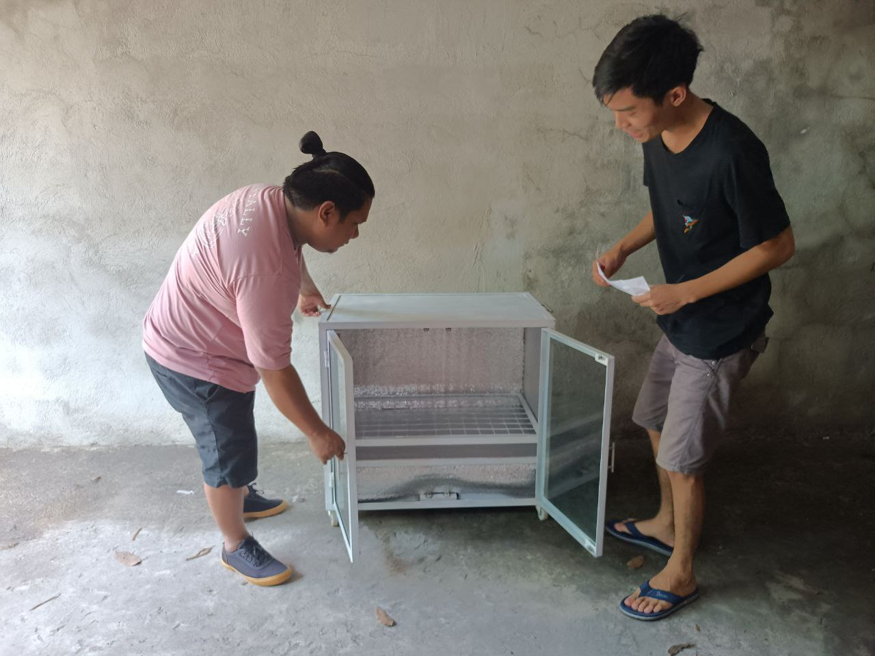

Figure 2. Random respondent inspecting the device.

**Flowchart of Research Design**

The figure below shows the flowchart of the research design:

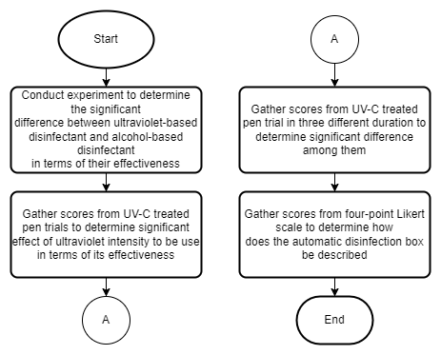

Figure 3. **Research Design Flowchart**

**Description of Research Instrument Used**

According to Cuevas R. V (2022), The unpaired two-samples Wilcoxon test is a non-parametric alternative to the unpaired two-samples t-test that can be used to compare two independent sets of samples. It is utilized when the data are not regularly distributed.

When the data cannot be assumed to be normally distributed, the one-sample Wilcoxon signed rank test is a non-parametric alternative to the one-sample t-test. It is used to determine whether the sample's median equals a recognized standard value or theoretical value (Cuevas R. V, 2022)

According Cuevas R. V (2022), The Kruskal-Wallis H test or one-way ANOVA is a rank-based nonparametric test that can be used to determine if there are statistically significant differences between two or more groups of an independent variable on a continuous or ordinal dependent variable.

The four-point Likert scale was used to assess the opinions of the respondents.

**Data Gathering Procedure**

The data for the statement of the problem number three are collected using a google form survey questionnaire after the device is implemented. The survey questionnaire created have questions modified from related research formed by the researchers. The survey covers the necessity, quality, price-quality ratio and approval. The survey was conducted for one month and the researcher’s assured confidentiality of their survey since the identities are not a requirement. The gathered data are used for the research after analyzing the survey answers.

**Statistical Treatment**

The Two-Samples Wilcoxon Test are used in statement of the problem 1 to determine the significant difference between ultraviolet-based disinfectant and alcohol-based disinfectant in terms of their effectiveness. One-Sample Wilcoxon Test are used in statement of the problem 2 to determine the significant effect of ultraviolet intensity to be use in terms of its effectiveness. Kruskal-Walis Test are used in the statement of the problem 3 to determine the significant difference among the different duration in terms of its effectiveness. The four-point Likert scale are used in statement of the problem 4a – 4d to allow participant to express how much they agree or disagree with the particular statement.

The table below shows the verbal descriptions of the values. The four-point Likert scale have statistical range of (1 – 1.74) for value 1, (1.75 - 2.49) for value 2, (2.5 - 3.24) for value 3, and (3.25 - 4) for value 4.

Table 1

**4-Point Likert Scale**

|  |  |  |  |  |
| --- | --- | --- | --- | --- |
| **Survey Question** | **Statistical Range (mean)** | | | |
| **1.00 - 1.74** | **1.75 - 2.49** | **2.5 - 3.24** | **3.25 - 4** |
| How well does the device meet current pandemic situation needs? | Extremely  Well | Very Well | Not so Well | Not at all Well |
| How would you rate the quality of the device? | Very High Quality | High Quality | Low Quality | Very Low Quality |
| With a price of 9,500 PHP, how would you rate the value for money of the device? | Excellent | Above  Average | Below Average | Poor |
| Overall, how satisfied or dissatisfied are you using the device or if you use the device? | Very  Satisfied | Somewhat Satisfied | Somewhat Dissatisfied | Very Dissatisfied |

The following computation obtains the statistical range.

**Max – Min = R**

4 – 1 = 3

**R / Max = Q**

¾ = 0.75

**Q + Min = Lower Limit**

lower Limits = 1, 1.75, 2.5, 3.25

**Lower Limit – 0.01 = Upper Limit**

1.75 - 0.01 = 1.74

**Next Upper Limit**

1.74 + 0.75 = 2.49

2.49 + 0.75 = 3.24

3.24 + 0.75 = 4

**Material Requirements**

The material gathered for the experiment are premixed nutrient agar (35g), sterile disposable petri plates (9cmx1.5cm), medical cotton swab, cling wrap, L-shaped rod, paper filter punchlets, distilled water, 70% isopropyl alcohol and the automatic disinfection box.

**Field Experiment**

To compare the effectiveness of alcohol-based and UV-based disinfection, Ms. Jerimi Francisco together with the researchers conduct streak and spread plate analysis on an empty sterile room in Camp Tinio, Nueva Ecija.

Four similar pens are prepared a day before and equally exposed to normal condition. Nutrient agar is prepared by adding 17.5g of premixed nutrient agar and 482.5mL of distilled water to obtain 500g agar solution. The solution is mixed and bring to a boil. After 5mins of non-stop stirring, the pot is removed from the heat to cool poured the solution to jars and pressured cook for 45mins at 15psi. The jars are removed from the pressure cooker, let it cool to 50 C and poured to prepared petri dishes. Five agar plates with three replications are prepared. Agar plate A (control), plate B (Alcohol exposure), plate C1 (10sec UV exposure), plate C2 (20sec UV exposure) and plate C3 (30sec UV exposure).

For plate A, pen 1 is not exposed to alcohol and UV disinfection. Using sterile medical swab, pen 1 surface is swab. After the hardening of the agar, using streak plate method, the agar is swab with it. The plate is secured then with cling wrap. The same procedure is done with the replications.

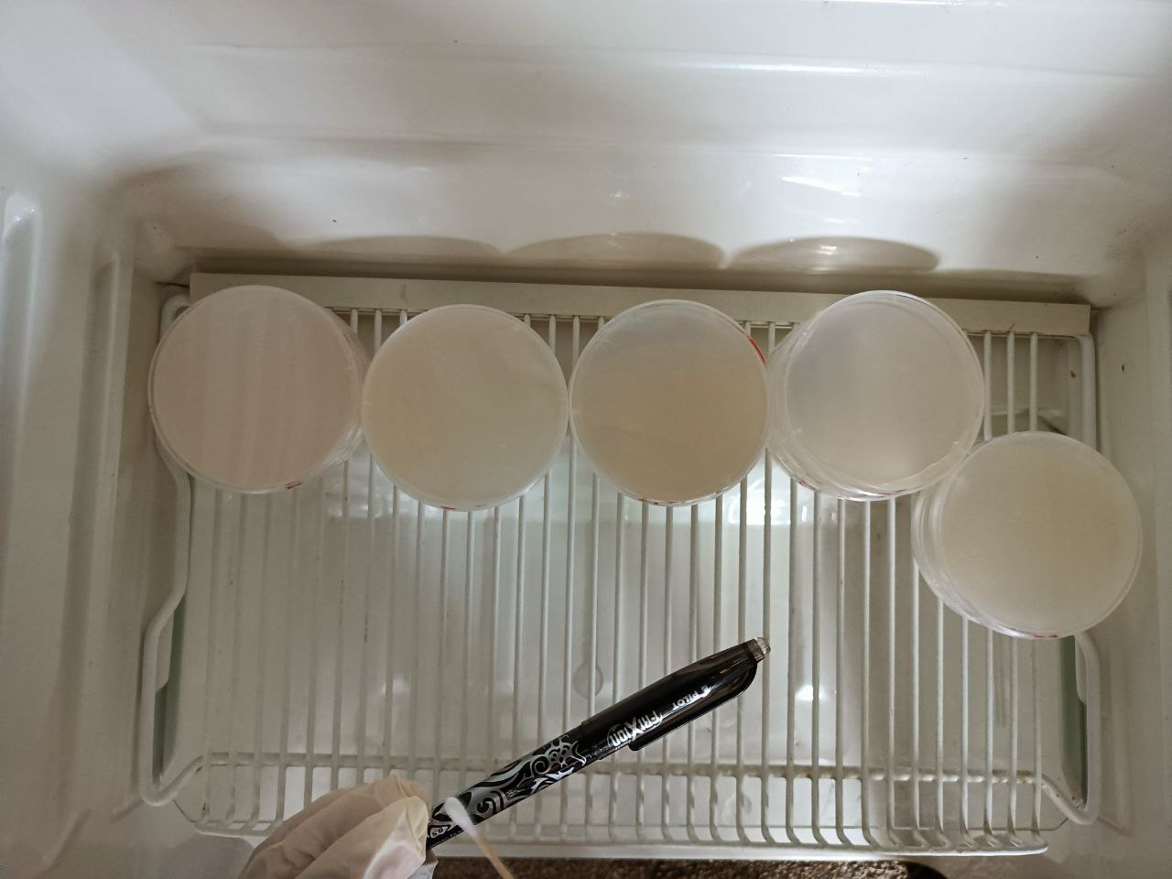

Figure 4. **Swabbing of Pen 1**

For plate B, pen 1 is swab with sterile L-shaped rod, using the rod, agar plate is prepared using spread plate technique. After the hardening of the agar, four paper filter punchlets soaked in 70% isopropyl alcohol are put to the four quadrants of the agar (disk diffusion method). The same procedure is done for the replications.

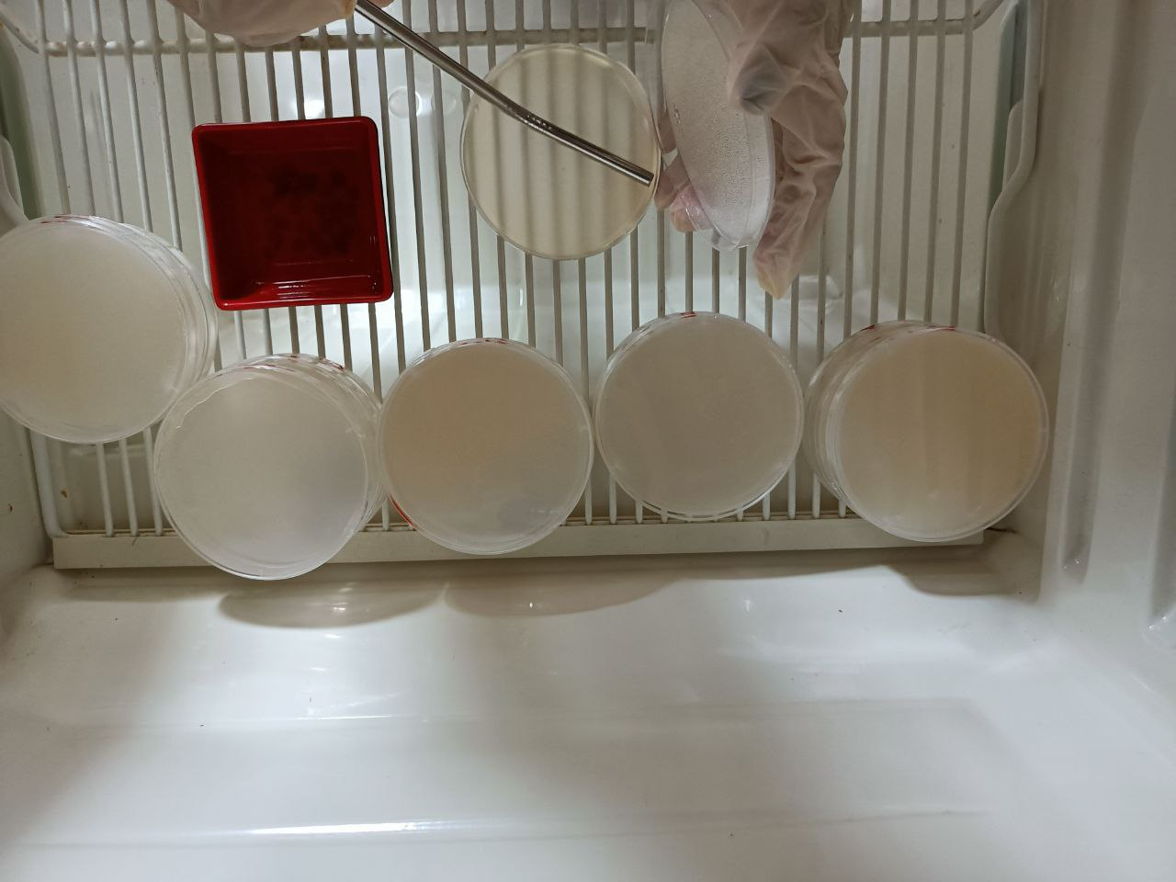

Figure 5. **Disk Diffusion on Plate B**

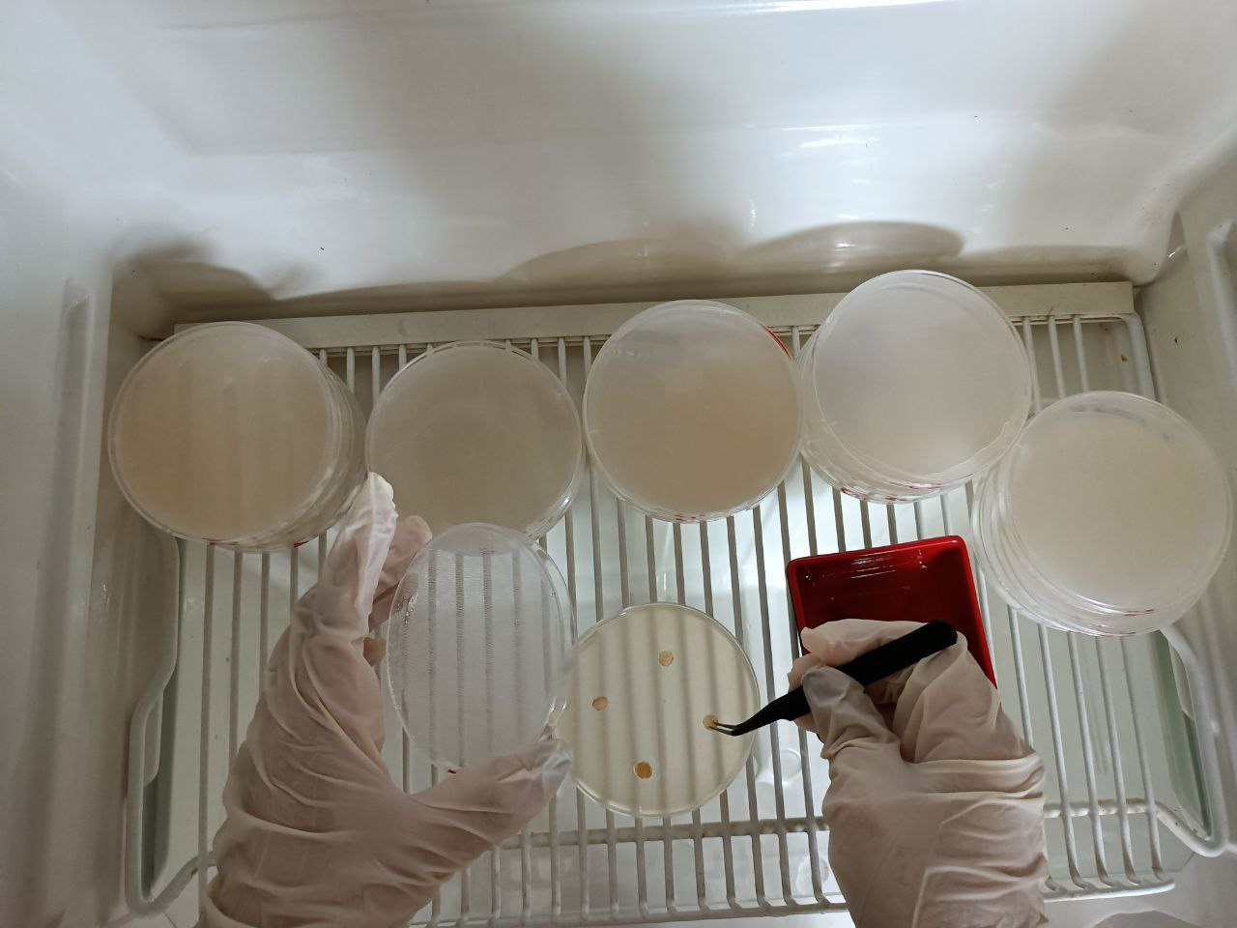

Figure 6. **Alcohol Punchlets on Plate B**

For plate C1, pen 2 is disinfected using the automatic disinfection for 10 seconds. Using sterile medical swab, the surface of the pen is swab. The plate C1 is swab using streak plate technique. The plate is secured with cling wrap. The same procedure was done with the replications.

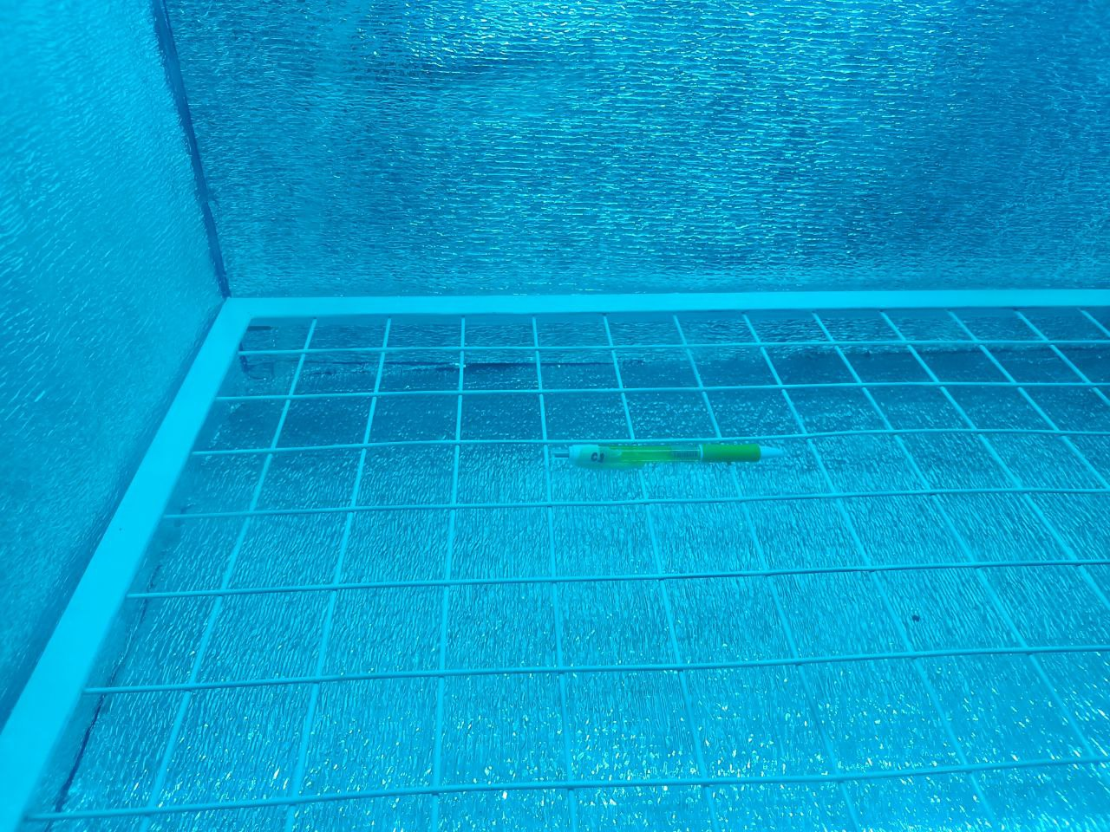

Figure 7. **UVC Exposure of Pen 2**

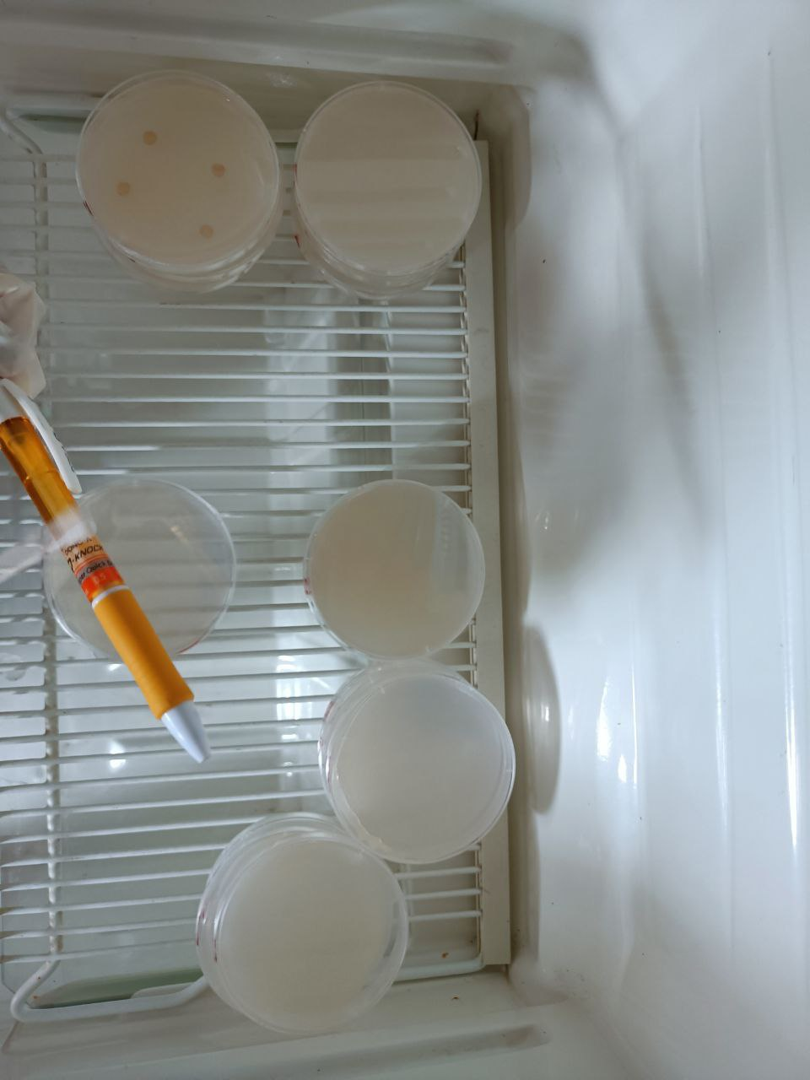

Figure 8. **Swabbing of Pen 2**

For plate C2, pen 3 is disinfected using the automatic disinfection for 20 seconds. Using sterile medical swab, the surface of the pen is swab. The plate C2 is swab using streak plate technique. The plate is secured with cling wrap. The same procedure was done with the replications.

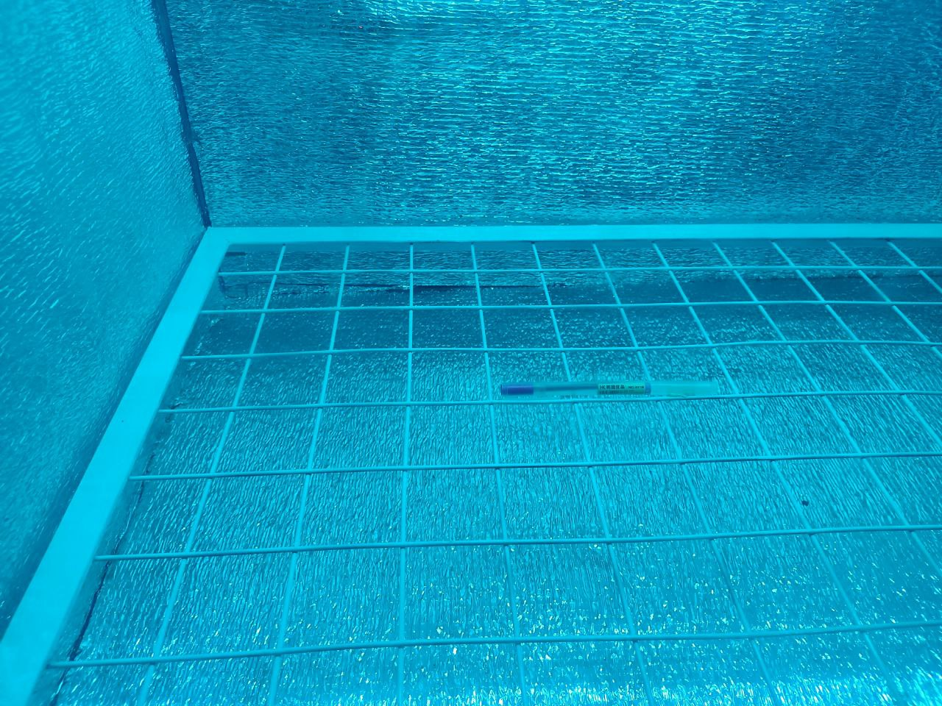

Figure 9. **UVC Exposure of Pen 3**

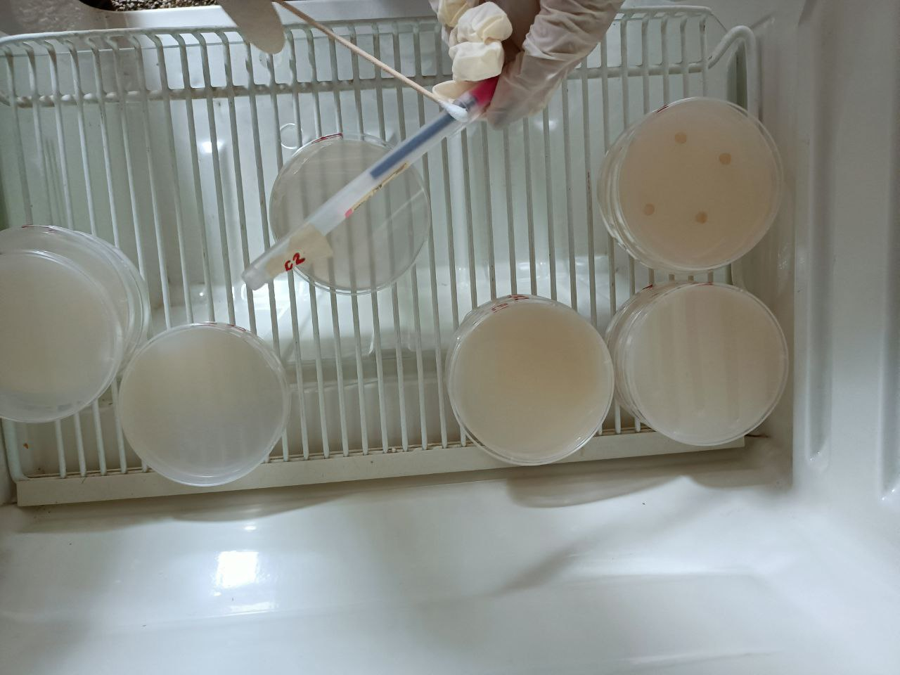

Figure 10. **Swabbing of Pen 3**

For plate C3, pen 4 is disinfected using the automatic disinfection for 30 seconds. Using sterile medical swab, the surface of the pen is swab. The plate C3 is swab using streak plate technique. The plate is secured with cling wrap. The same procedure was done with the replications.

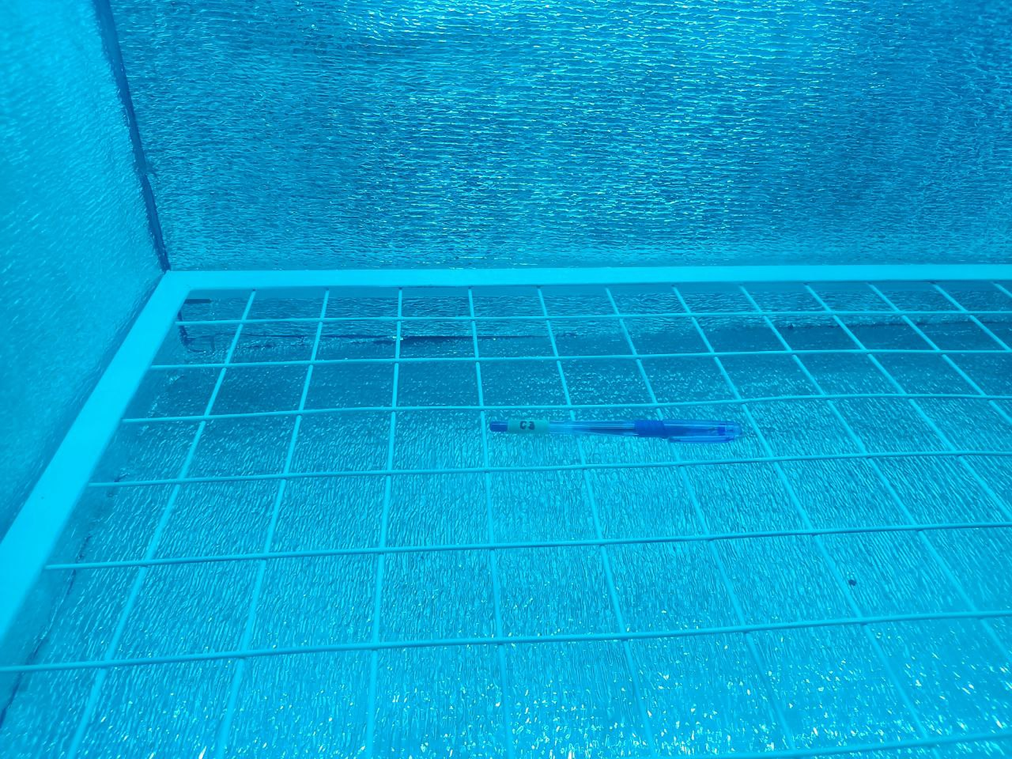

Figure 11. **UVC Exposure of Pen 4**

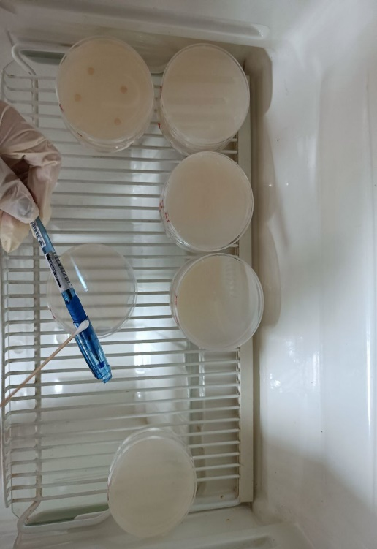

Figure 12. **Swabbing of Pen 4**

**Chapter 4**

**RESULTS AND DISCUSSION**

This chapter includes the presentation of the proposed system from components to detailed procedure, analysis of the data gathered from the research design, and the interpretation of data.

1. **Statistical Analysis of UV Based and Alcohol Disinfectant Data.**

All statistical analyses were performed using R Studio v 4.2.1 and all test of significance were evaluated at 5% level provided by Cuevas R. V. (2022).

Effectiveness of UV based and Alcohol based disinfectant were measured based on number of colonies in different treatments. Different treatments were replicated thrice and were compared to a baseline treatment wherein the agar plate was not exposed to UV or Alcohol. Results revealed that the baseline treatment was relatively higher compared to Alcohol based and UV based treatments. This suggests that Alcohol based and UV based disinfectant were more effective in terms of bacterial inhibition.

**Statement of the Problem 1.** What is the significant effect of ultraviolet intensity to be use in terms of its effectiveness?

***Null Hypothesis*.** There is no significant effect of UV intensity to be use in terms of effectiveness.

***Alternative Hypothesis*.** There is a significant effect of UV intensity to be use in terms of effectiveness.

***Result of One-Sample Wilcoxon Test.***

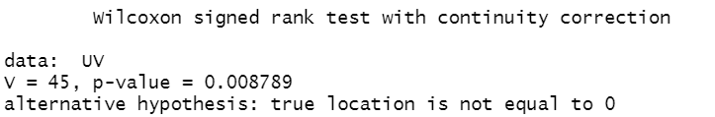

Figure 33. **One Sample Wilcoxon Test**

***Conclusion.*** Since the One-Sample Wilcoxon Test resulted a p-value of 0.0088, and is less than 5% level of significance (0.05), it was therefore concluded that UV intensity has a significant effect in terms of effectiveness. This result supports the comparison of findings of Baseline treatment and UV based treatments in terms of bacterial inhibition since number of colonies from UV based treatments were lower than those from the former.

**Statement of the Problem 2.** What is the significant difference among the different duration in terms of its effectiveness?

***Null Hypothesis*.** There is no significant difference among the duration of 10 seconds, 20 seconds, and 30 seconds in terms of its effectiveness.

***Alternative Hypothesis*.** There is a significant difference among the duration of 10 seconds, 20 seconds, and 30 seconds in terms of its effectiveness.

***Result of Kruskal-Walis Test.***

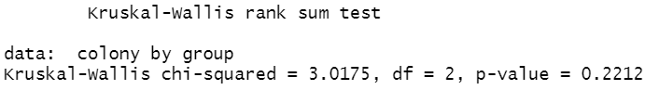

Figure 34. **Kruskal-Walis Test**

***Conclusion.*** Since the Kruskal-Walis test yields a p-value of 0.2212, and is greater than 5% level of significance (0.05), therefore, the different durations of UV exposure show no significant difference in terms of effectiveness.

**Statement of the Problem 3a.** How does the automatic disinfection box be described in terms of necessity, quality, price-quality ratio, and approval?

***Statistical Analysis of Responses in terms of Necessity.***

The following table shows the statistical mean of the responses.

Table 2

**Response Mean in terms of Necessity**

|  |  |  |
| --- | --- | --- |
| **Survey Question** | **Weighted Mean** | **Verbal Description** |
| How well does the device meet current pandemic situation needs? | 1.36 | Extremely Well |

In terms of necessity, the mean value of 1.36 falls under the statistical range of 1 – 1.74 with the verbal interpretation of Extremely Well.

***Statistical Analysis of Responses in terms of Quality.***

The following table shows the statistical mean of the responses.

Table 3

**Response Mean in terms of Quality**

|  |  |  |
| --- | --- | --- |
| **Survey Question** | **Weighted Mean** | **Verbal Description** |
| How would you rate the quality of the device? | 1.43 | Very High Quality |

In terms of quality, the mean value of 1.43 falls under the statistical range of 1 – 1.74 with the verbal interpretation of Very High Quality.

***Statistical Analysis of Responses in terms of Price-Quality Ratio.***

The following table shows the statistical mean of the responses.

Table 4

**Response Mean in terms of Price-Quality Ratio**

|  |  |  |
| --- | --- | --- |
| **Survey Question** | **Weighted Mean** | **Verbal Description** |
| With a price of 9,500 PHP, how would you rate the value for money of the device? | 2.15 | Above Average |

In terms of price-quality ratio, the mean value of 2.15 falls under the statistical range of 1.75 - 2.49 with the verbal interpretation of Above Average.

***Statistical Analysis of Responses in terms of Approval.***

The following table shows the statistical mean of the responses.

Table 5

**Response Mean in terms of Approval**

|  |  |  |
| --- | --- | --- |
| **Survey Question** | **Weighted Mean** | **Verbal Description** |
| Overall, how satisfied or dissatisfied are you using the device or if you use the device? | 1.49 | Very Satisfied |

In terms of approval, the mean value of 1.49 falls under the statistical range of 1 – 1.74 with the verbal interpretation of Very Satisfied.

***Statistical analysis of Statement Problem 3.***

The following table shows the summary of the statistical mean of the responses.

Table 6

**Overall Survey Question Response Mean**

|  |  |  |  |
| --- | --- | --- | --- |
| **Statement of the Problem** | **Corresponding Survey Question** | **Weighted Mean** | **Verbal Description** |
| How does the automatic disinfection box be described in terms of necessity? | How well does the device meet current pandemic situation needs? | 1.36 | Extremely Well |
| How does the automatic disinfection box be described in terms of quality? | How would you rate the quality of the device? | 1.43 | Very High Quality |
| How does the automatic disinfection box be described in terms of price-quality ratio? | With a price of 9,500 PHP, how would you rate the value for money of the device? | 2.15 | Above Average |
| How does the automatic disinfection box be described in terms of Approval? | Overall, how satisfied or dissatisfied are you using the device or if you use the device? | 1.49 | Very Satisfied |
| **Overall Mean** | 1.61 | | |
| **Respondents** | 114 | | |

**Device Description Analysis.**

The researchers use convenience sampling as a non-probability sampling method due to resource limitation in collecting feedback. The method yields a total 114 responses. The researchers adapt Cuevas R. V (2022) four-point Likert scale, where value one leans to strongly agree and value four leaning to strongly disagree.

**Statement of the Problem 4.** Is there a significant difference between ultraviolet-based disinfectant and alcohol-based disinfectant in terms of their effectiveness?

***Null Hypothesis.*** There is no significant difference between UV based disinfectant and Alcohol based disinfectant in terms of their effectiveness.

***Alternative Hypothesis.*** There is a significant difference between UV based disinfectant and Alcohol based disinfectant in terms of their effectiveness.

***Result of Two-Samples Wilcoxon Test.***

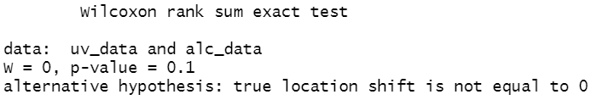

Figure 32. **Two Sample Wilcoxon Test**

***Conclusion.*** Since the p-value of 0.1 is greater than 5% level of significance (0.05), there is enough evidence to conclude that UV and Alcohol based disinfectant exhibit no significant difference when it comes to their effectiveness.

**Components of the Proposed System**

The researchers’ components of the proposed system are Arduino uno r3 for microcontroller board. AC relay module kit with outlet plug and wire for Arduino control of 220v AC load, 10 ohms and 100 ohms resistors, passive infrared sensor, I2C LCD display 16x2, GSM module, sim900 GPRS shield, wire, 5v power supply and FYL201 germicidal UV tube.

**Device Implementation**

The model development stage consists stages of modeling, design and analysis. The researchers study different sanitation chamber, ultra violet chamber and sanitation device. The researchers ponder that the chamber must have the capability and strength to hold and sanitize objects with size of at least 50cm in height and width. After studying different sanitation chamber models and considering the researchers requirements, the researchers come up with the following model dimension

.

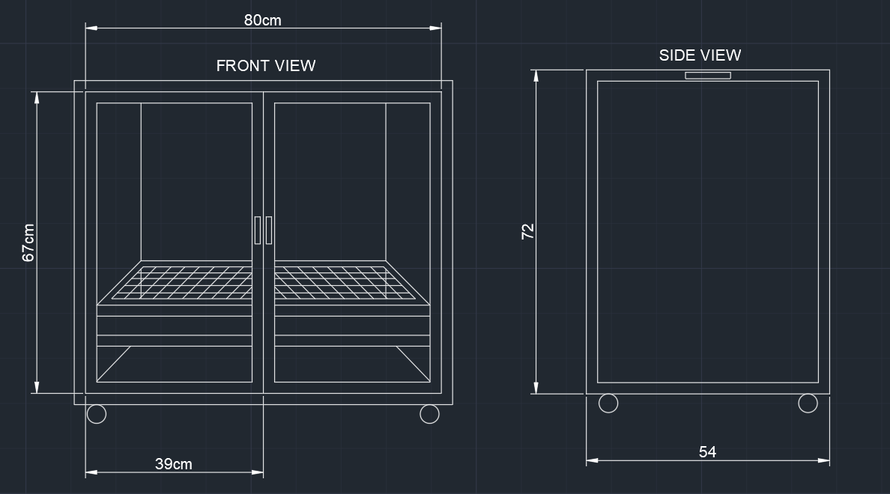

Figure 13. Front and Side View of the Device

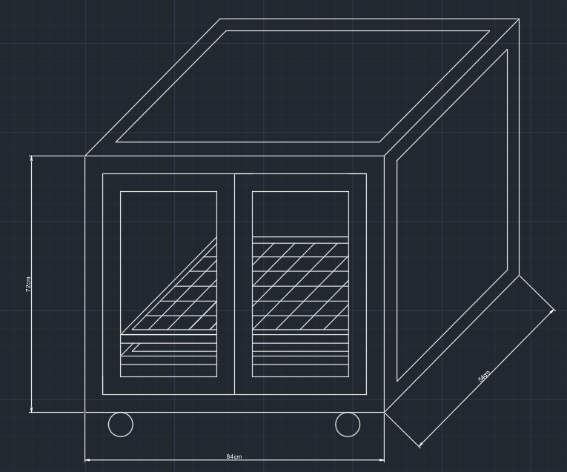

Figure 14. 3-Dimensional View of the Device

The researcher’s requirement must have also that the device is mobile and have the capability to move around effortlessly. the device must also have the capability to smoothly insert objects inside the chamber. The device must also conform to quality standards and have the capability to blend to commercial sanitation chambers in market. The researchers come up with the design in figure 14.

The design analysis data are gathered from the four-point Likert scale Specifically, how does the automatic disinfection box be described in terms of necessity, quality, price-quality ratio and approval.

**Disinfection Distance**

According to felcostore (2022), FYL201 has a coverage area of 15-20 sqm. Using the beam angle formula, we can calculate the beam angle to determine the diameter of the object or the effective illuminated surface.

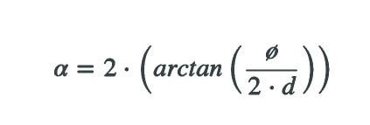

Where:

α: Beam angle

Ø: Diameter of the object or surface to be illuminated

d: Distance between lamp and object or surface

arctan: Inverse function of the tangent for angle calculation

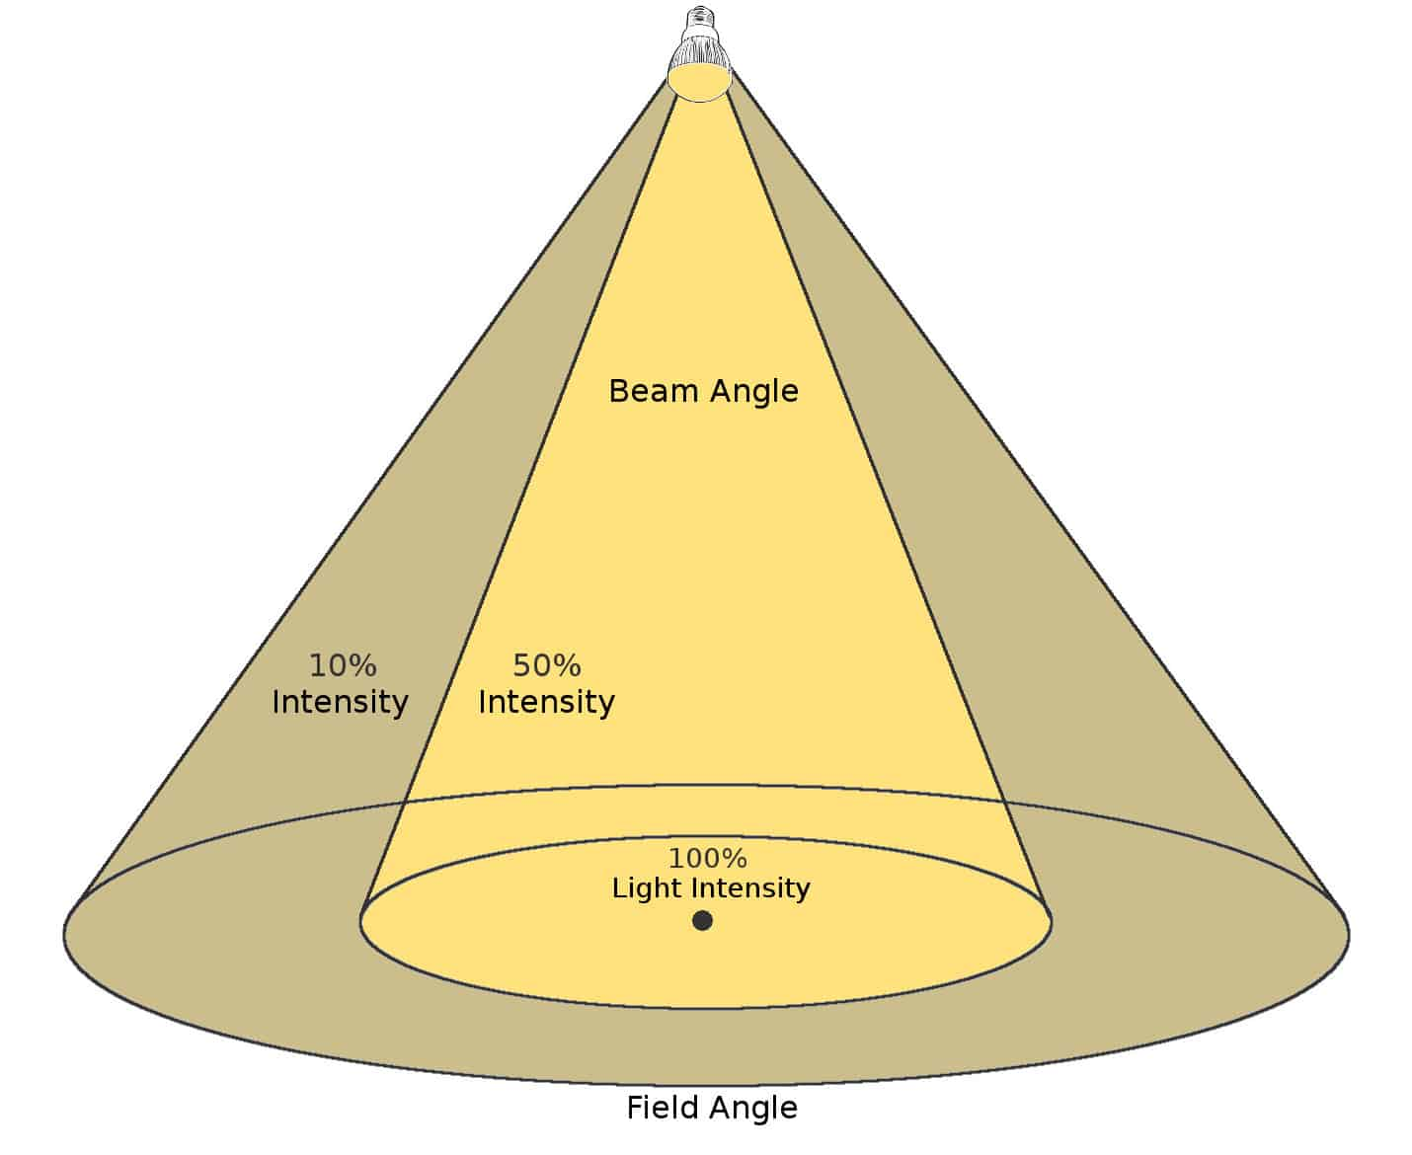

Figure 15. Beam Angle

By inserting values to the formula, the effective spot light diameter of the automatic disinfection box is 4.5 ft. By reducing the distance of the illuminated object from the lamp, the illuminated object remains inside the 100% intensity area. Following considerations for a beam angle, the beam angle of 120 degrees of the lamp has a very good diffusion of light for the automatic disinfection box.

**Materials and Specifications**

The following are the materials used for the disinfection box.

L- bracket or angle bar ¼ x 1 in size.

Galvanized steel sheet with measurement of 4x8 in 0.9 thickness.

Flat steel bars.

Nylon caster wheels (swivel).

Galvanized steel matting.

¼ thick clear glass.

Stainless cabinet handle.

Cylindrical hinges 3/8.

Roller catches.

Glass silicone sealant.

Teks screw.

Reflective Insulation foam.

Rugby glue.

Aerosol paint color white and clear for coating

**Detailed Procedure of Device Implementation**

Angle bars with measurement each of 72, 84 and 54cm. are prepared using angle grinder. A welding machine is use to weld the pieces together into the shape of the frame.

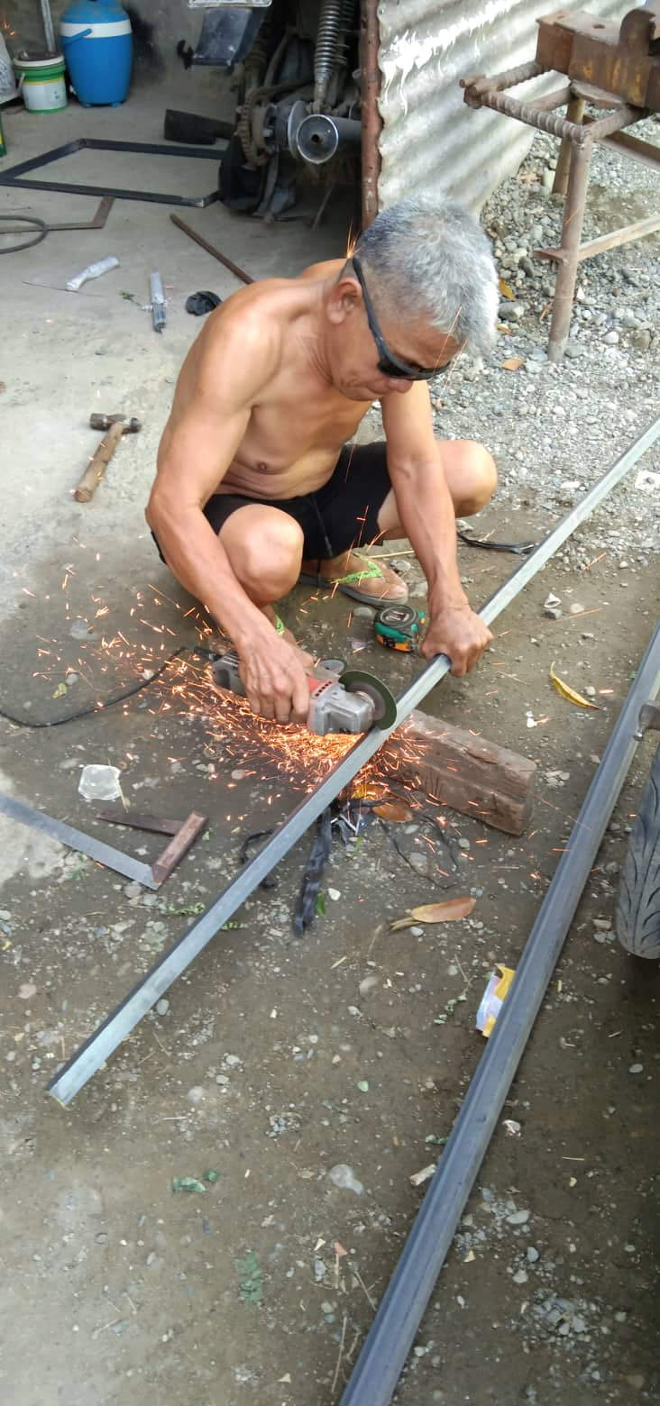

Figure 16. Welding of Angle Bars

Having the rigid frame, the frame is turned upside down to weld the caster wheels on each corner of the frame as to give the frame maneuverability.

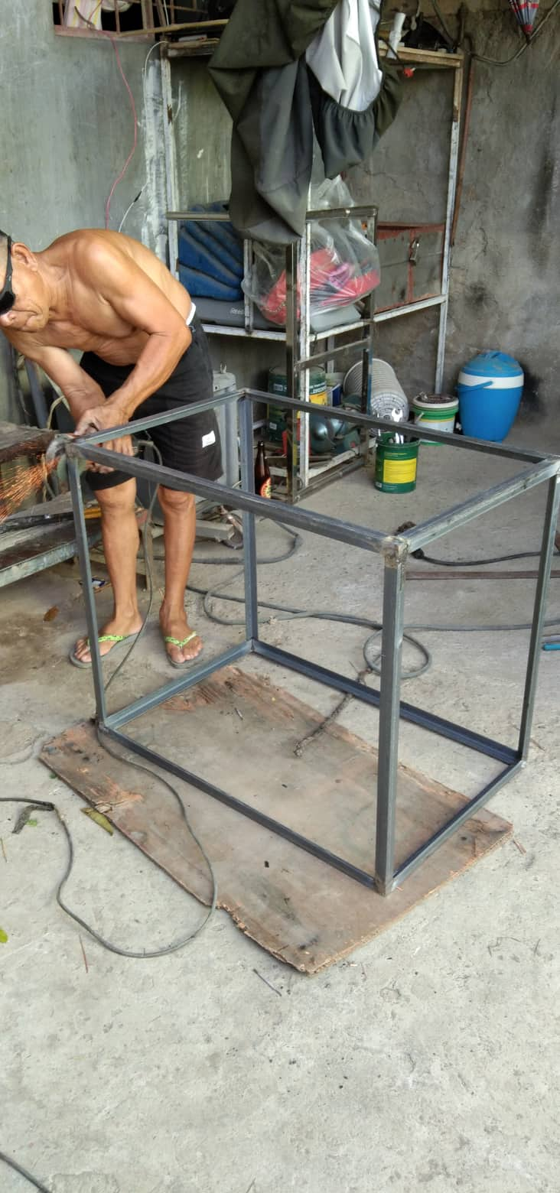

Figure 17. Rigid Frame

A 39 and 67cm angle bars are prepared using the angle grinder and welded into shape of a door frame.

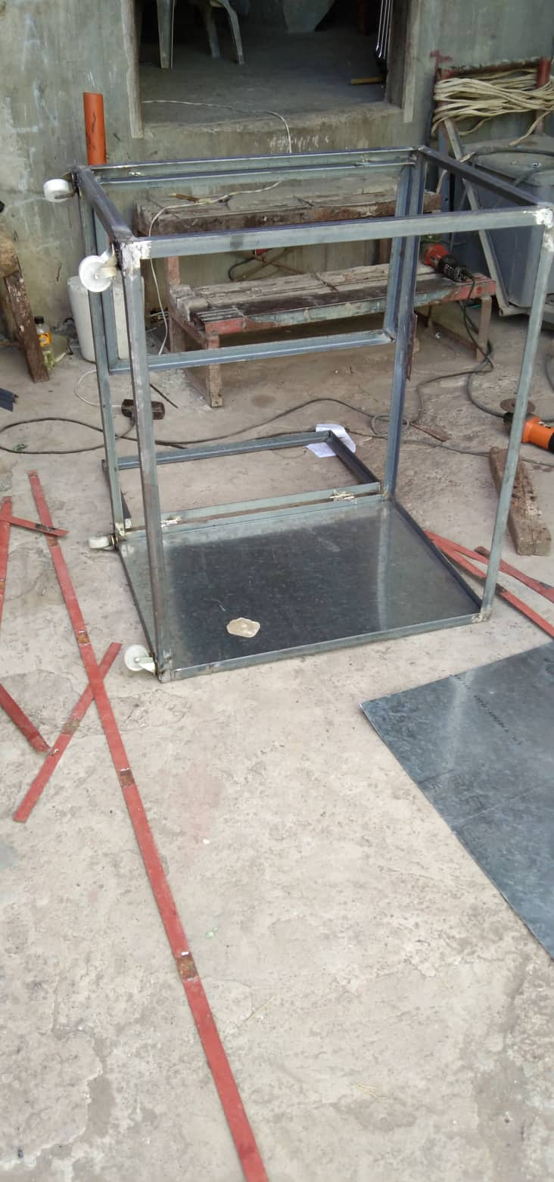

Figure 18. Rigid Frame Upside Down

The door was fixed to the frame using cylindrical hinges. Roller catches are fixed onto the front top and bottom center of the frame.

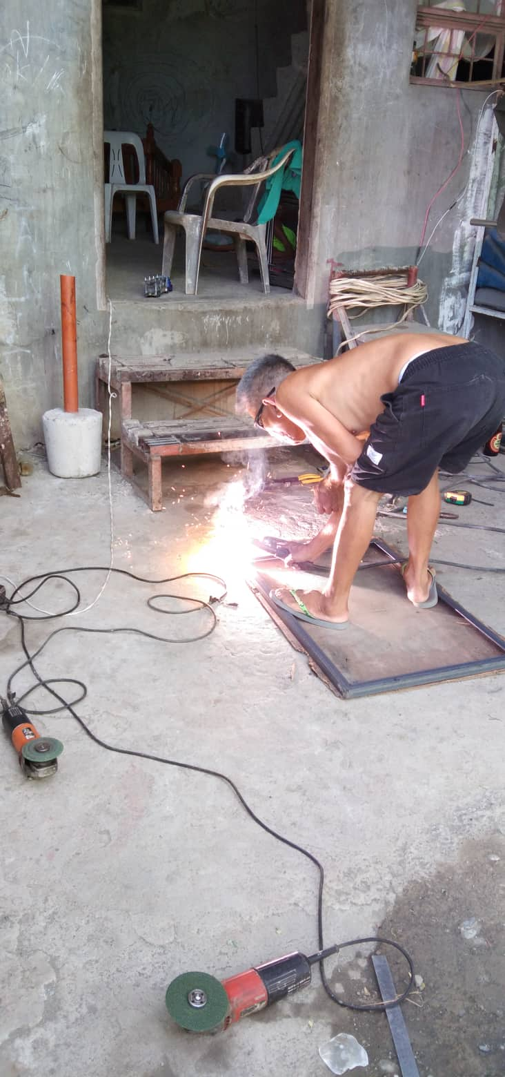

Figure 19. Welding of Door Frames

After turning the frame upright, galvanized steel walls are cut and prepared. Using the welding machine, the steel walls are fixed onto the frame reinforcing with flat bars.

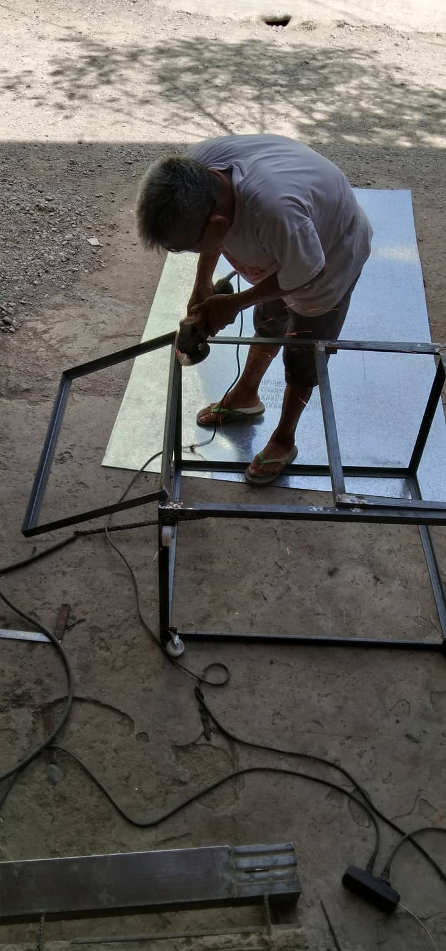

Figure 20. Attaching of Door Frames

Using a measuring tape to have the center of the door frame, two holes were drilled. The aluminum handle bars are screwed onto the frame. Using the same technique, two holes were drilled on the side of the frame and aluminum handle bars are fixed using screws onto the frame.

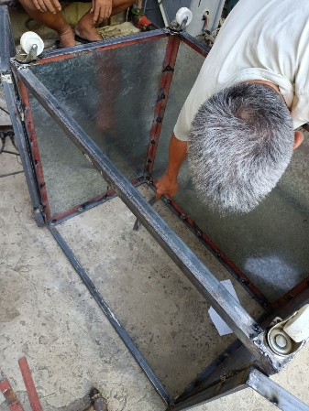

Figure 21. Steel Walls

Using the angle grinder, the frame was sanded off of sharp edges. After smoothing the frame, using aerosol paint, a white coat was applied inside and outside the frame.

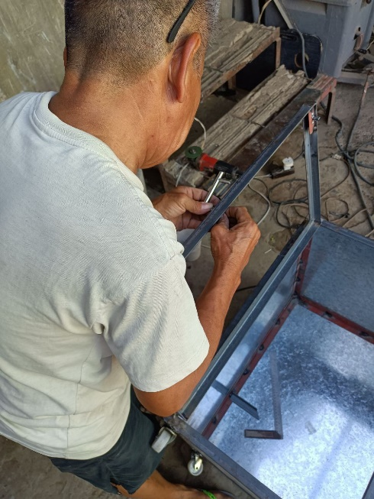

Figure 22. Sanding of Rigid Frame

A clear coat was applied after drying of the primer. A two 49 and 81cm angle bar are prepared and welded into a shape of rectangle and galvanized wire mesh are cut accordingly to the dimension and welded onto the shape. The mesh, who serves as the object holder are coated with primer and clear coat also.

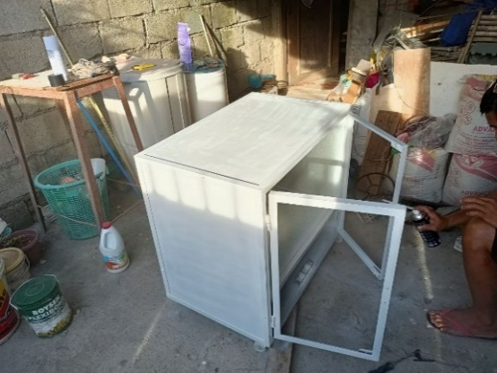

Figure 23. Applying Aerosol Paint

The wire mesh and the circuit chamber divider are fixed onto the inside of the frame using teks screw.

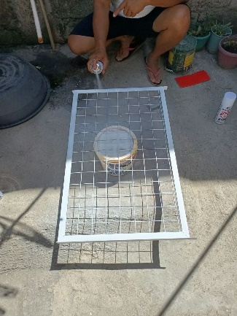

Figure 24. Mesh Panel

¼ inch thick clear glass are fixed onto the door frame using glass silicon putty.

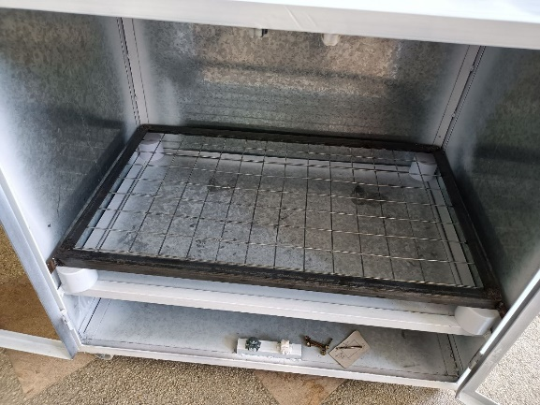

Figure 25. Fixed Mesh Panel

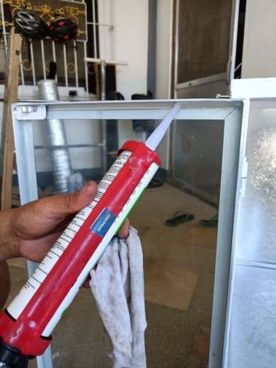

Figure 26. Applying Silicon

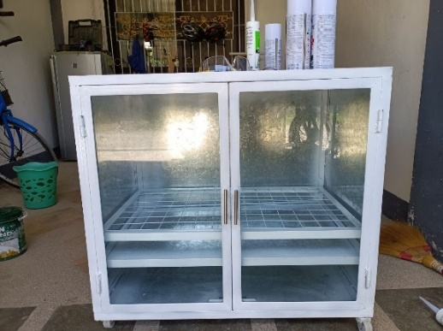

Figure 27. Automatic Disinfection Box

**Block Diagram**

The figure below shows the block diagram of the circuit.

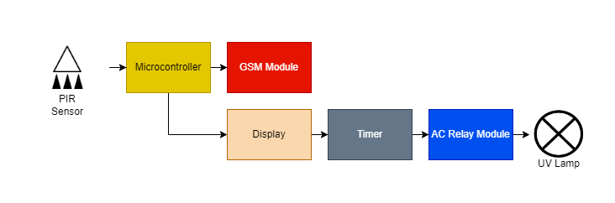

Figure 28. Circuit Block Diagram

**Flow Chart**

The figure below shows the flowchart of the circuit.

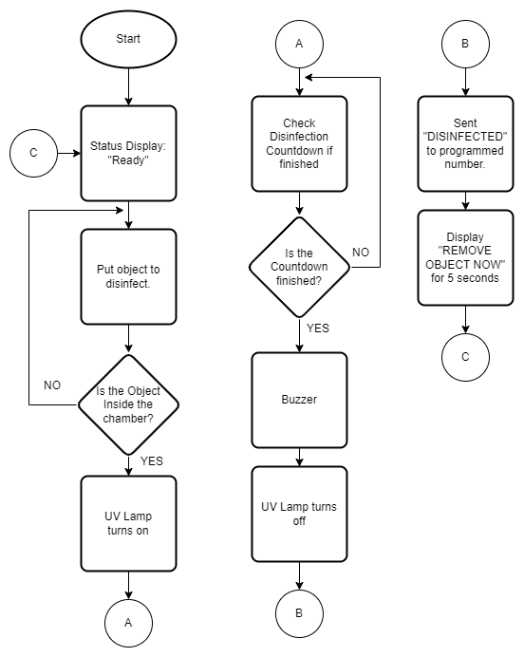

Figure 29. Circuit Flowchart

**Component Analysis**

The researchers’ components of the proposed system are Arduino uno r3 for microcontroller board. AC relay module kit with outlet plug and wire for Arduino control of 220v AC load, 10 ohms and 100 ohms resistors, passive infrared sensor, a I2C LED display 16x2 IC2, GSM module, sim900 GPRS shield, wire, 5v power supply and Firefly Yellow Shield Antivirus and Germicidal UV Tube Set.

Arduino Uno R3 is a 14 input/output pinned microcontroller which has a 16-Megahertz ceramic resonator, USB connection, a power jack, an ICSP header and a reset button. This is a microcontroller that can be programmed and as such, can be the only microcontroller you will ever need in creating complicated systems.

Arduino Uno can only handle up to 5 volts and can malfunction when applied at a higher voltage, much more when using 220 AC volts into it. The AC Relay module kit helps the microcontroller to handle up to said voltage that is in the description of the module. In the module used in the project, the researchers specifically used a 220v AC load.

Resistors are static components that help regulate the current running in a circuit. The higher the resistance(ohms), the lesser the current(amp). In the project, the researchers specifically used 10 ohms and 100 ohms values of resistors.

Passive Infrared Sensors or PIR Sensors is used to detect an object that is in front of it and act as a switch to a circuit. It activates the circuit when the object is detected by the infrared. This is commonly used in automatically triggered lighting devices and protection systems. In the project, the researchers used it as a detector for the object or item placed inside the chamber to automatically start the disinfection process.

LED Displays are displays that are commercially used in the market because of their efficiency and low-energy consumption. These displays are made up of a series of LED panels which contain LEDs that can be used in a variety of ways from providing light to sending a message. The researchers used a Grove, 16x2 LED display which can be programmed with the use of Arduino Uno and is used to display the status of the disinfection process.

GSM (Global System for Mobile Communications) Module is a chip that can be used to provide the option to send SMS (short messages service) messages in a system. This chip has an antenna to receive and send out transmissions and a slot for the sim card which will be used to send out messages to other devices. The sim900 GPRS shield is the specific model used by the researchers. Despite the small size of the model, this packs many features and is one of the latest models.

The circuit created by the researchers is connected by copper wires. Copper wires are most commonly used in circuits for its conductivity and these wires are covered by rubber for insulation.

Power supplies are components that supply power to at least one load. This is used to provide and regulate a consistent value of current to a load to avoid any inconsistency to the load that can cause complications and malfunctions for the load. The researchers used specifically a 5v power supply that is used to supply power to the Arduino Uno.

UV lights are lights that are capable of disinfecting surfaces within a prolonged period of time under a specific range of intensities. The researchers used Firefly Yellow Shield Antivirus and Germicidal UV Tube Set which has an intensity of 222 nm, operates at a 230 V at 60 Hz, and covers the range of 15 to 20 square meters.

According to felcostore (2022), the FYL201 disinfects, sterilizes, kills bacteria, germs and viruses, coronavirus, influenza virus, mites, anthrax, Hepa B, and dysentery bacteria. The FYL201 disinfecs e-coli, staphylococcus aureus, candida albicans, pseudomonas aeruginosa.

The FYL201 is a quartz lamp cap, filament core, mercury pill lamp type with a UVC length of 222nm. It has an operating voltage of 230V - 60Hz. With an 15-20 sqm coverage area and a dimension of 624 x 48 x 70mm (felcostore, 2022).

According to the Americanultraviolet (2022), Germicidal UVC lamps do not produce much heat and about the same as fluorescent lamps. fluorescent lamps don’t use resistance to emit light, they emit about 75% less heat than an incandescent bulb. As a result, they save energy and keep whatever room they’re in at a cooler temperature.

**Schematic Diagram**

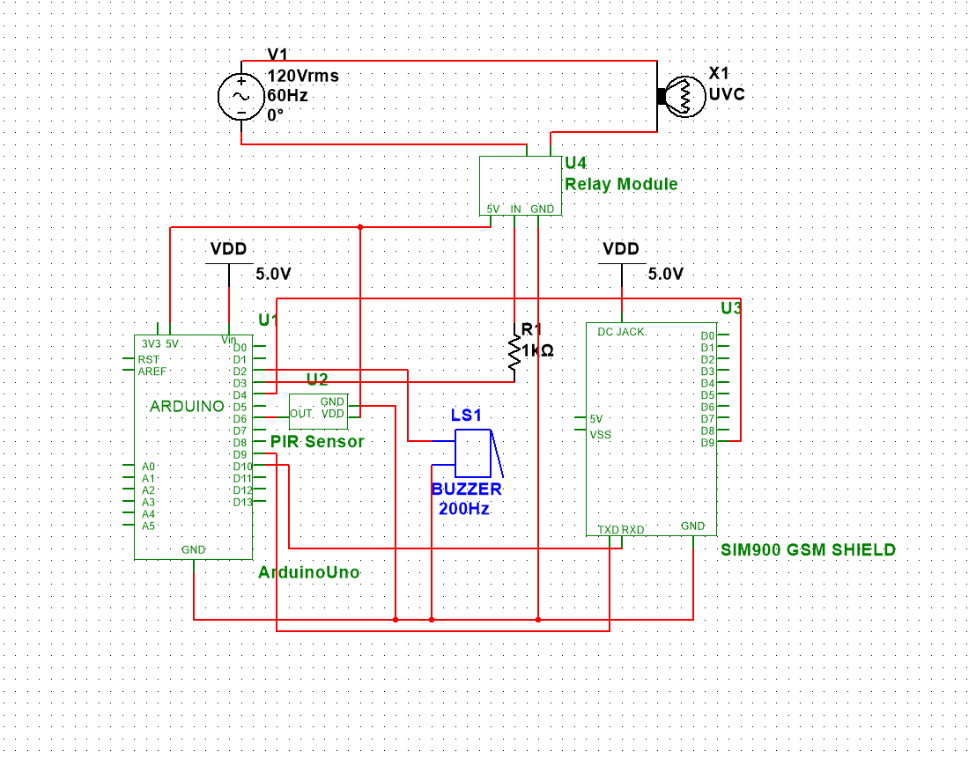

Figure 30.Schematic Diagram

**Fabrication of the Device**

Connect the GND pins of PIR Sensor, Buzzer, SIM900, and Relay Module to the GND pin of Arduino. Then, connect the source pin of PIR Sensor and Relay Module to the 5V pin of Arduino. After that, connect the TXD and RXD pins of SIM900 to pins 9 and 10 of Arduino respectively. Connect pin 2 of Arduino to the positive pin of the buzzer, then connect the OUT pin of PIR Sensor to pin 6 of Arduino. After that, connect the pin 9 of SIM900 to pin 4 of Arduino. And then connect the pin 3 of Arduino to a 1k resistor then connect the other end of the resistor to the IN pin of Relay Module. Lastly, connect an AC source to the relay module to power up the UVC lamp.

The circuit is soldered in a printed circuit board and placed in the circuit box of the automatic disinfection box.

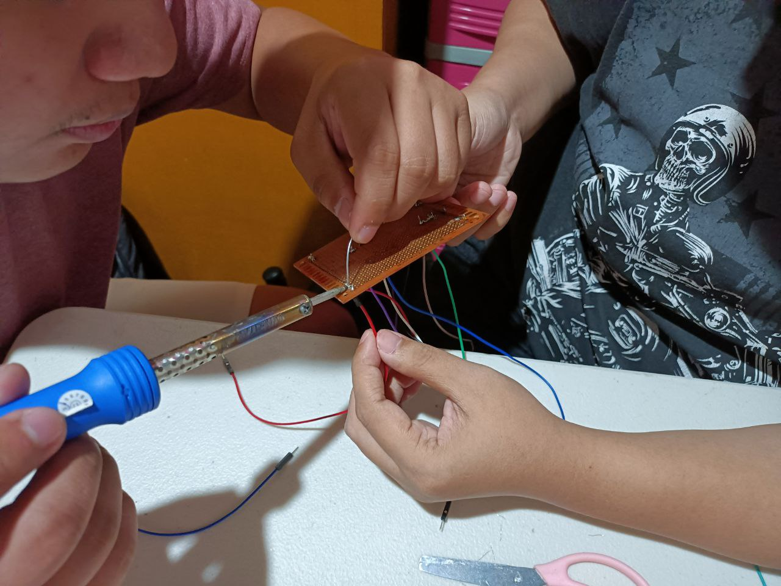

Figure 31. Soldering of Components

**Field Experiment**

The following shows the analysis report provided by Francisco (2022) from the streak and spread plate analysis to compare the effectiveness of alcohol-based and UV-based disinfection. Agar plates are incubated for twenty-four hours to allow visible colony growth. Colonies are counted in every replication. Scores are gathered for data comparison.

Table 1

**Experiment Analysis**

|  |  |  |  |  |  |
| --- | --- | --- | --- | --- | --- |
| **Agar Plate** | **Microbiological Culture Technique** | **No. of**  **Colonies** | **Colony Mean** | **Colony Size Average (cm)** | **Zone of Inhibition Average** |
| A1 | Streak Plate Method | 44 | 22.66 | 0.36 | NA |
| A2 | 7 | NA |
| A3 | 17 | NA |
| B1 | Spread Plate Method | 9 | 9.66 | 0.193 | 0.681 cm |
| B2 | 13 |
| B3 | 7 |
|  | | | | | |
| C1 | Streak Plate Method | 6 | **4.33**  **(10 sec)** | 0.126 | NA |
| C1 | 5 | NA |
| C1 | 2 | NA |
|  | | | | | |
| C2 | Streak Plate Method | 4 | **3.66**  **(20 sec)** | 0.1 | NA |
| C2 | 3 | NA |
| C2 | 4 | NA |
|  | | | | | |
| C3 | Streak Plate Method | 3 | **2.33**  **(30 sec)** | 0.87 | NA |
| C3 | 2 | NA |
| C3 | 2 | NA |

Legends:

a(1-3) – control

b(1-3) – alcohol

c1 – 10 sec UV

c2 – 20 sec UV

c3 – 30 sec UV

Agar plate A1 with microbial culture technique of streak plate method produce 44 colonies. Plate A2 produce 7 colonies and A3 produce 17 colonies. The Three replication produce an average of 22.66 colonies with an average colony size of 0.35 cm.

Agar plate B1 with microbial culture technique of spread plate method produce 9 colonies. Plate B2 produce 13 colonies and B3 produce 7 colonies. The Three replication produce an average of 9.66 colonies with an average colony size of 0.193 cm with a zone of inhibition average of 0.681 cm.

Agar plate C1 with microbial culture technique of streak plate method produce 6 colonies. Replication 2 produce 5 colonies and replication 3 produce 2 colonies. The Three replication produce an average of 4.33 colonies with an average colony size of 0.126 cm.

Agar plate C2 with microbial culture technique of streak plate method produce 4 colonies. Replication 2 produce 3 colonies and replication 3 produce 4 colonies. The Three replication produce an average of 3.66 colonies with an average colony size of 0.1 cm.

Agar plate C3 with microbial culture technique of streak plate method produce 3 colonies. Replication 2 produce 2 colonies and replication 3 produce 2 colonies. The Three replication produce an average of 2.33 colonies with an average colony size of 0.87 cm.

**Chapter 5**

**SUMMARY OF FINDINGS, CONCLUSIONS AND RECOMMENDATIONS**

This chapter presents the summary of the findings, conclusion and the recommendations on how to improve the study.

**Summary**

The summary were made based on the results and discussions, proof of effectivity of the device such as certificate of analysis of Automatic Disinfection Box and Certification of Statistical Treatment

1. Since the One-Sample Wilcoxon Test resulted a p-value of 0.0088, and is less than 5% level of significance (0.05), it was therefore concluded that UV intensity has a significant effect in terms of effectiveness. This result supports the comparison of findings of Baseline treatment and UV based treatments in terms of bacterial inhibition since number of colonies from UV based treatments were lower than those from the former.
2. Since the Kruskal-Walis test yields a p-value of 0.2212, and is greater than 5% level of significance (0.05), therefore, the different durations of UV exposure show no significant difference in terms of effectiveness.
3. In terms of necessity, the mean value of 1.36 falls under the statistical range of 1 – 1.74 with the verbal interpretation of Extremely Well. In terms of quality, the mean value of 1.43 falls under the statistical range of 1 – 1.74 with the verbal interpretation of Very High Quality. In terms of price-quality ratio, the mean value of 2.15 falls under the statistical range of 1.75 - 2.49 with the verbal interpretation of Above Average. In terms of approval, the mean value of 1.49 falls under the statistical range of 1 – 1.74 with the verbal interpretation of Very Satisfied.
4. Since the p-value of 0.1 is greater than 5% level of significance (0.05), there is enough evidence to conclude that UV and Alcohol based disinfectant exhibit no significant difference when it comes to their effectiveness.

**Conclusion**

The following conclusion were made based on the findings, proof of effectivity of the device such as certificate of analysis of Automatic Disinfection Box and Certification of Statistical Treatment

1. UV intensity has a significant effect in terms of effectiveness and this result supports the comparison of findings of Baseline treatment and UV based treatments in terms of bacterial inhibition since number of colonies from UV based treatments were lower than those from the former.
2. The different durations of UV exposure of 10, 20, 30 seconds show no significant difference in terms of effectiveness.
3. Based on the statistical analysis, the automatic disinfection meets current pandemic situation extremely well, the automatic disinfection box has a very high quality in terms of quality, have an above average price-quality price ratio and the respondents are very satisfied using the automatic disinfection box.
4. There is enough evidence to conclude that UV and Alcohol based disinfectant exhibit no significant difference when it comes to their effectiveness.

**Recommendations**

The researchers recommend the following suggestions to further develop and revolutionize the study.

1. Make a real-time UVC dosage monitor module that shows the current UVC dosage of the device producing.
2. Develop a BIOS of the system to save the current settings, device health, UVC lamp life.
3. Improve by letting maintainer input their mobile phone number where the device is going to send the message. The length of the message can also be improved by adding more information to the message.
4. Add feature that when the registered number of the device received a “STATUS” the device will send the current status of the device.
5. Expand device by a self-disinfect feature on the device handles to reduce transmission of virus and microorganisms.
6. Construct buttons to the device like power switch to make it more intuitive.

**References**

Acasestudy (2021). What is qualitative research design? Methods and types. Retrieved from <https://acasestudy.com/what-is-qualitative-research-design-methods-and-types/>

AIS (2022). How to choose the right beam angle for LED lights. Retrieved from <https://www.aisledlight.com/choose-right-beam-angle-led-lights/>

Aisha et. Al (2018). Effect of ultraviolet radiation on the growth of microorganisms developing on cave wall paintings. Retrieved from <https://aip.scitation.org/doi/abs/10.1063/1.5048178?journalCode=apc#:~:text=UV%2DC%20at%20a%20wavelength,the%20end%20of%20the%20treatment>.

Alba et. Al. (2021). Microbiological Evaluation of the Disinfecting Potential of UV-C and UV-C Plus Ozone Generating Robots. Retrieved from <https://www.mdpi.com/2076-2607/9/1/172>

American Ultraviolet. frequently Asked Questions about UVC. Retrieved from <https://www.americanultraviolet.com/germicidal-healthcare-solutions/frequently-asked-questions-about-UVC.html>

Arduino.cc (2022). UNO R3. Retrieved from <https://docs.arduino.cc/hardware/uno-rev3>

Baes, F. (n.d.). Hps.org. Health Physics Society. Retrieved July 24, 2022, from <https://hps.org/publicinformation/ate/q9450.html>

Barnard et. Al. (2020). Further Evidence That Far-UVC for Disinfection Is Unlikely to Cause Erythema or Pre-Mutagenic DNA Lesions in Skin. Retrieved from <https://doi.org/10.1111/phpp.12580>.

Bhandari P. (2020). An introduction to quantitative research. Retrieved from <https://www.scribbr.com/methodology/quantitative-research/>

Brenner D. (2020). Far-UVC Light to Limit Airborne Transmission of SARS-CoV-2 … and All Other Viruses. Retrieved from <https://www.nationalacademies.org/event/09-16-2020/the-second-gilbert-w-beebe-webinar-safety-and-efficacy-of-uvc-to-fight-covid-19>.

Buonanno, M. (2020, December 23). Far-UVC light (222ânm) efficiently and safely inactivates airborne human coronaviruses. Scientific Reports. Retrieved from <https://www.nature.com/articles/s41598-020-67211-2>

Buonanno, M. et. Al. (2019). Germicidal Efficacy and Mammalian Skin Safety of 222-nm UV Light. Retrieved from <https://doi.org/10.1667/RR0010CC.1>.

Buonanno, M. et. Al. (2020). Far-UVC Light (222 nm) Efficiently and Safely Inactivates Airborne Human Coronaviruses. Retrieved from <https://doi.org/10.1038/s41598-020-67211-2>.

Casini, B., & Tuvo, B. (2019, September 24). Evaluation of an ultraviolet C (UVC) light-emitting device for disinfection of high touch surfaces in hospital critical areas. International journal of environmental research and public health. Retrieved July 25, 2022, from <https://www.ncbi.nlm.nih.gov/pmc/articles/PMC6801766/>

Cesarini, J.-P. (2019). UV-C photocarcinogenesis risks from germicidal lamps. CIE. Retrieved July 25, 2022, from <https://cie.co.at/publications/uv-c-photocarcinogenesis-risks-germicidal-lamps>

Childress J. (March 22, 2021). Using 222-nm Ultraviolet (UV) Light for Safer Disinfection. Retrieved from <https://www.dsiac.org/resources/articles/using-222-nm-ultraviolet-uv-light-for-safer-disinfection/>

Dahal (2022). Spread Plate Method- Definition, Principle, Procedure, Uses. Retrieved from <https://microbenotes.com/spread-plate-technique/>

Dahal (2022). Streak Plate Method- Principle, Types, Methods, Uses. Retrieved from <https://microbenotes.com/streak-plate-method-principle-methods-significance-limitations/>

DOST (May 22, 2020). DOST-X, PARAS JOIN HANDS IN DEVELOPING PARAZAP DISINFECTION UNIT FOR COVID-19. Retrieved from <https://www.dost.gov.ph/knowledge-resources/news/67-2020-news/1823-dost-x-paras-join-hands-in-developing-parazap-disinfection-unit-for-covid-19.html>

Electronicsforu.com (2021). All You Wanted to Know About GSM Module and GPRS Module. Retrieved from <https://www.electronicsforu.com/resources/gsm-module>

Eubanas G. et. Al. (2021, February 26). Are ultraviolet lamps effective in infection prevention and control of COVID-19 infections in public spaces in locations with sustained community transmission? Retrieved from <https://www.psmid.org/wp-content/uploads/2021/04/NPI_UV-Lamps_20210405.pdf>

FDA. (2020). Ultraviolet (UV) radiation. U.S. Food and Drug Administration. Retrieved July 25, 2022, from <https://www.fda.gov/radiation-emitting-products/tanning/ultraviolet-uv-radiation>

Felco Store (2022). Firefly Yellow Shield Antivirus & Germicidal UV Tube Set. Retrieved from <https://www.felcostore.ph/products/firefly-yellow-shield-antivirus-germicidal-uv-tube-set?variant=42080995639460>

Felcostore.ph (2022). Firefly Yellow Shield Antivirus & Germicidal UV Tube Set. Retrieved from <https://www.felcostore.ph/products/firefly-yellow-shield-antivirus-germicidal-uv-tube-set>

Geiger D. (2020). UV Light Helps Duke Hospitals Fight Transmission of Superbugs. Retrieved from <https://www.dukehealth.org/blog/uv-light-helps-duke-hospitals-fight-transmission-of-superbugs>

Griffiths, A. (2022, June 30). UV-C dose required to kill microorganisms. UV Light Technology. Retrieved July 24, 2022, from <https://uv-light.co.uk/uv-dosage-required-to-kill-microorganisms/>

Heilingloh, C. S., Aufderhorst, U. W., & Schipper, L. (2020, August 4). Susceptibility of SARS-COV-2 to UV irradiation. American Journal of Infection Control. Retrieved July 24, 2022, from <https://www.ajicjournal.org/article/S0196-6553(20)30756-2/fulltext>

Jamieson S. (2022). Likert Scale. Retrieved from <https://www.britannica.com/topic/Likert-Scale>

Kitagawa et. Al. (2020). Effectiveness of 222-nm Ultraviolet Light on Disinfecting SARS-CoV-2 Surface Contamination. Retrieved from <https://doi.org/10.1016/j.ajic.2020.08.022>.

Kodoth et. Al. (2020). The Effects of Ultraviolet Light on Escherichia coli. Retrieved from <https://emerginginvestigators.org/articles/the-effects-of-ultraviolet-light-on-em-escherichia-coli-em>

Kosta G. (2020). UV-C Penetrable Plastic & Materials. Retrieved from <https://start.askwonder.com/insights/uv-c-penetrable-plastic-and-materials-2-5li2z1mx1>

Lamp HQ (2022). LED Beam Angle Guide – With Beam Angle Calculator. Retrieved from <https://lamphq.com/beam-angle/>

lastminuteengineers.com (2022). Interface One Channel Relay Module with Arduino. Retrieved from <https://lastminuteengineers.com/one-channel-relay-module-arduino-tutorial/>

lastminuteengineers.com (2022). Send Receive SMS & Call with SIM900 GSM Shield & Arduino. Retrieved from <https://lastminuteengineers.com/sim900-gsm-shield-arduino-tutorial/>

LightSources. (2022, January 2). Does UV light kill covid-19? LightSources. Retrieved July 24, 2022, from <https://www.light-sources.com/blog/does-uv-light-kill-covid/>

Merriam-webster (2021). Germicidal. Retrieved from <https://www.merriam-webster.com/dictionary/germicidal>

Merriam-webster (2021). In vitro. Retrieved from <https://www.merriam-webster.com/dictionary/in%20vitro>

Merriam-webster (2021). Irradiation. Retrieved from <https://www.merriam-webster.com/dictionary/irradiation>

Minnesota Department of Health (2022). About Staphylococcus aureus. Retrieved from <https://www.health.state.mn.us/diseases/staph/basics.html#:~:text=aureus%20is%20spread%2C%20common%20symptoms,infections%20are%20not%20serious%2C%20S>

Miranda et. Al. (2020, October 21). Analysis of UV technologies for disinfection of public areas: a systematic literature review. Retrieved from <https://ieeexplore.ieee.org/abstract/document/9253754?fbclid=IwAR2ZIPL8WVGAXAzu379fXSjJ6rwLkVijhjGHk1Bo6ucP3jneVs5suzv99Yo>

NationalAcademies (2021). Does ultraviolet kill the coronavirus? Retrieved from <https://www.nationalacademies.org/based-on-science/covid-19-does-ultraviolet-light-kill-the-coronavirus>

NCI Dictionary of Cancer terms. National Cancer Institute. (2022). Microorganism. Retrieved from <https://www.cancer.gov/publications/dictionaries/cancer-terms/def/microorganism>

Oguma et. Al. (2020). Photoreactivation of Escherichia Coli After Low- or Medium-Pressure UV Disinfection Determined by an Endonuclease Sensitive Site Assay. Retrieved from [https://doi.org/10.1128/aem.68.12. 6029-6035.2002](https://doi.org/10.1128/aem.68.12.%206029-6035.2002).

Oxford English Dictionary (2020). "Covid-19". Retrieved from <https://www.oxfordlearnersdictionaries.com/us/definition/english/covid-19>

Pelczar, M. (2022). The study of Microorganisms. Encyclopedia Britannica. Retrieved from <https://www.britannica.com/science/microbiology/The-study-of-microorganisms>

PHILIPPINE DERMATOLOGICAL SOCIETY PHOTODERMATOLOGY SUBSPECIALTY CORE GROUP. (2020, July). GUIDELINES ON UV DISINFECTION. Retrieved from <https://pds.org.ph/pds_new/wp-content/uploads/2020/06/UV-Disinfection-Guidelines-PDS-06112020-FINAL.pdf>

Ploydaeng et. Al. (2020). UV-C light: A powerful technique for inactivating microorganisms and the related side effects to the skin. Retrieved from <https://onlinelibrary.wiley.com/doi/10.1111/phpp.12605>

Pullerits et. Al (2020). Impact of UV irradiation at full scale on bacterial communities in drinking water. Retrieved from <https://www.nature.com/articles/s41545-020-0057-7>

QuestionPro (2022). Types of Sampling: Sampling Methods with Examples. Retrieved from <https://www.questionpro.com/blog/types-of-sampling-for-social-research/>

Ramos C. et. Al. (2020, November 14). Use of ultraviolet-C in environmental sterilization in hospitals: A systematic review on efficacy and safety. Retrieved from <https://www.ncbi.nlm.nih.gov/pmc/articles/PMC7644456/?fbclid=IwAR3_L3UDxff7C4FMC9y1SMXL-QtE87HGos9iSe1Say9nFvZ7C-54GVSEddY>

Resonance Ltd. (2021). "What is an Excimer Lamp?". Retrieved from <http://resonance.on.ca/excimer.htm>

Sciencedirect (2022). Passive Infrared Sensor. Retrieved from <https://www.sciencedirect.com/topics/computer-science/passive-infrared-sensor>

Sciencedirect.com (2022). Copper wire. Retrieved from <https://www.sciencedirect.com/topics/engineering/copper-wire>

Sharma (2022). Kirby Bauer Disc Diffusion Method For Antibiotic Susceptibility Testing. Retrieved from <https://microbenotes.com/kirby-bauer-disc-diffusion/>

sparkfun.com (2022). Resistors. Retrieved from [https://learn.sparkfun.com/tutorials/resistors/all#](https://learn.sparkfun.com/tutorials/resistors/all)

Staff. (2020, September 14). What is the difference between UVA UVB UVC? which is most dangerous? LED Lighting Distributor and Implementation Company. Retrieved July 24, 2022, from <https://www.stouchlighting.com/blog/uva-uvb-uvc-differences>

Taylor et. Al. (2019). Effectiveness of UV-C light irradiation on disinfection of an eSOSÂ® smart toilet evaluated in a temporary settlement in the Philippines. (2016). Retrieved from <https://www.tandfonline.com/doi/abs/10.1080/09603123.2016.1217313>

Technopedia.com (2017). LED Display. Retrieved from <https://www.techopedia.com/definition/14957/led>

Technopedia.com (2017). Power supply. Retrieved from <https://www.techopedia.com/definition/1756/powersupply#:~:text=A%20power%20supply%20is%20a,provides%20components%20with%20electric%20power>

Thefreedictionary.com (2021). UVB. Retrieved from https://medical-dictionary.thefreedictionary.com/UVB

Tyrell, D. (2020, March 10). Coronaviruses - Medical Microbiology - NCBI Bookshelf. Medical Microbiology. 9th Edition. Retrieved from <https://www.ncbi.nlm.nih.gov/books/NBK7782/>

U.S Food and Drug Administration (2022). UV Lights and Lamps: Ultraviolet-C Radiation, Disinfection, and Coronavirus. Retrieved from <https://www.fda.gov/medical-devices/coronavirus-covid-19-and-medical-devices/uv-lights-and-lamps-ultraviolet-c-radiation-disinfection-and-coronavirus>

Ultraviolet (UV) radiation. American Cancer Society. (2019). Retrieved July 25, 2022, from <https://www.cancer.org/healthy/cancer-causes/radiation-exposure/uv-radiation.html>

Violet Defense (2020). Understanding the Power of Light to Kill Germs. Retrieved from <https://www.violetdefense.com/howitworks>

Walker D. et. Al. (2019). Effect of Ultraviolet Germicidal Irradiation on Viral Aerosols. Retrieved from https://doi.org/10.1021/es070056u.

Worldometer (July 2021). COVID-19 CORONAVIRUS PANDEMIC. Retrieved from <https://www.worldometers.info/coronavirus/>

Yamano N. et. Al. (2020). Long-Term Effects of 222-nm Ultraviolet Radiation C Sterilizing Lamps on Mice Susceptible to Ultraviolet Radiation. Retrieved from <https://doi.org/10.1111/PHP.13269>.

Yang et. Al. (2019). Effectiveness of an ultraviolet-C disinfection system for reduction of healthcare-associated pathogens. Retrieved from <https://pubmed.ncbi.nlm.nih.gov/28951015/>

Yang, J.-H., Wu, U.-I., Tai, H.-M., & Sheng, W.-H. (2019, September 18). Effectiveness of an ultraviolet-C disinfection system for reduction of healthcare-associated pathogens. Journal of Microbiology, Immunology and Infection. Retrieved July 24, 2022, from https://www.sciencedirect.com/science/article/pii/S1684118217302001



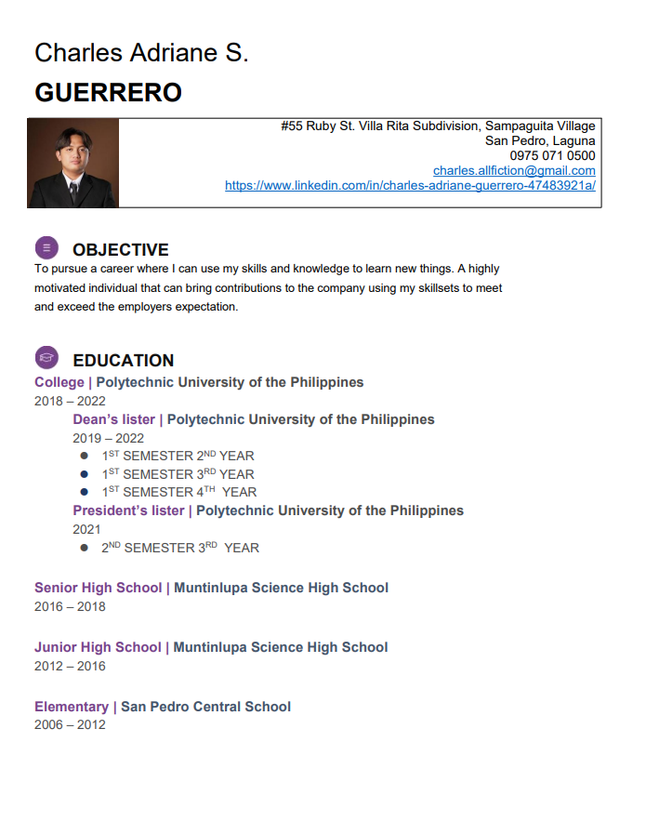







**APPENDICES**

**Appendix 1: Letter of Intent**

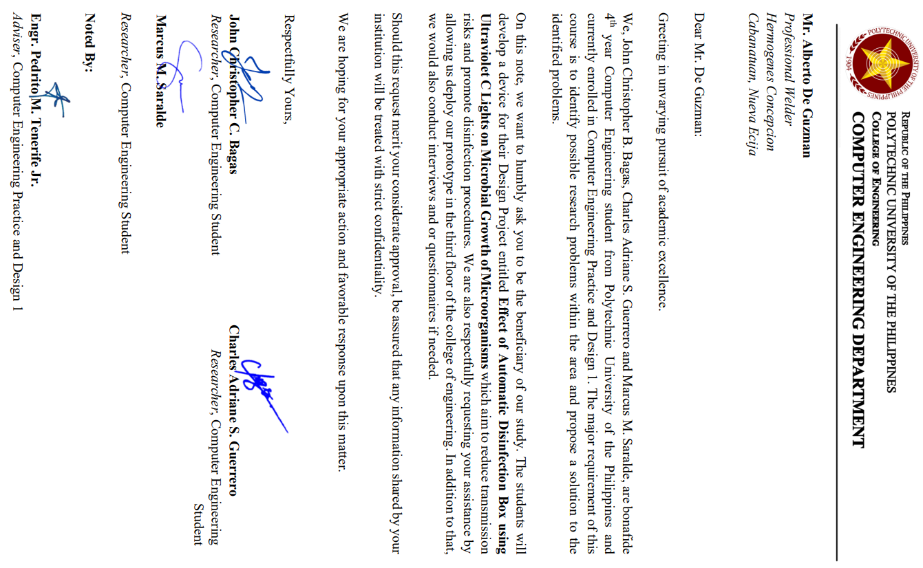

**Appendix 2: Design Project Proposal Defense 2021**

DESIGN PROJECT PROPOSAL DEFENSE 2021

SUMMARY OF COMMENTS

REPORT

**NO.:** CPERC-2021-PROP-POE-R-000060

|  |  |  |  |  |
| --- | --- | --- | --- | --- |
| **GROUP CODE** |  | 3609 | **ADVISER** | Engr. Pedrito M. Tenerife Jr. |
| **SECTION** |  | BSCpE 3-6 |
|  |  |  | | |
| **THESIS TITLE** |  | Development of Automatic Covid Disinfection Box Implemented with Arduino (ADB Automatic Disinfection Box) | | |

|  |  |
| --- | --- |
|  | **NAME OF PANEL** |
| **PANEL CHAIR** | Dr. Remedios G. Ado |
| **PANEL MEMBER 1** | Engr. Arlene B. Canlas |
| **PANEL MEMBER 2** | Engr. Jonathan C. Manarang |

|  |  |  |
| --- | --- | --- |
|  | **COMMENTS** | **RECOMMENDATIONS** |
| **PANEL CHAIR** | Consider the comments and suggestions of the panel of evaluator to improve the project. | think of an alternative application solution to justify the need of this project & with 4 members in a team. |
| **PANEL MEMBER 1** |  | Consider adding how to verify the effectivity/ effectiveness of your disinfection device. Maximize the use of Arduino (example: sending sms about the status of the disinfection and the device) |
| **PANEL MEMBER 2** | Add gsm shield for sending message to the owner of the item being sanitized. Apply this prototype to laboratory subjects, include the counting of object being sanitized. Provide clinical lab test result in front of your subject to denote that it is calibra. |  |

**NOTE:** The data shown above are acquired from the filled-out Panel Evaluation Form in Google Forms. Should there be any error on this report, please notify the CpE Research Committee for verification.

**Appendix 3: Letter of Permission to**

**Conduct Experiment**

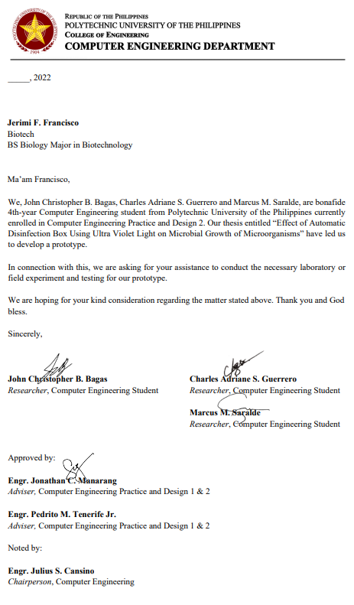

**Appendix 4: Initial Draft**

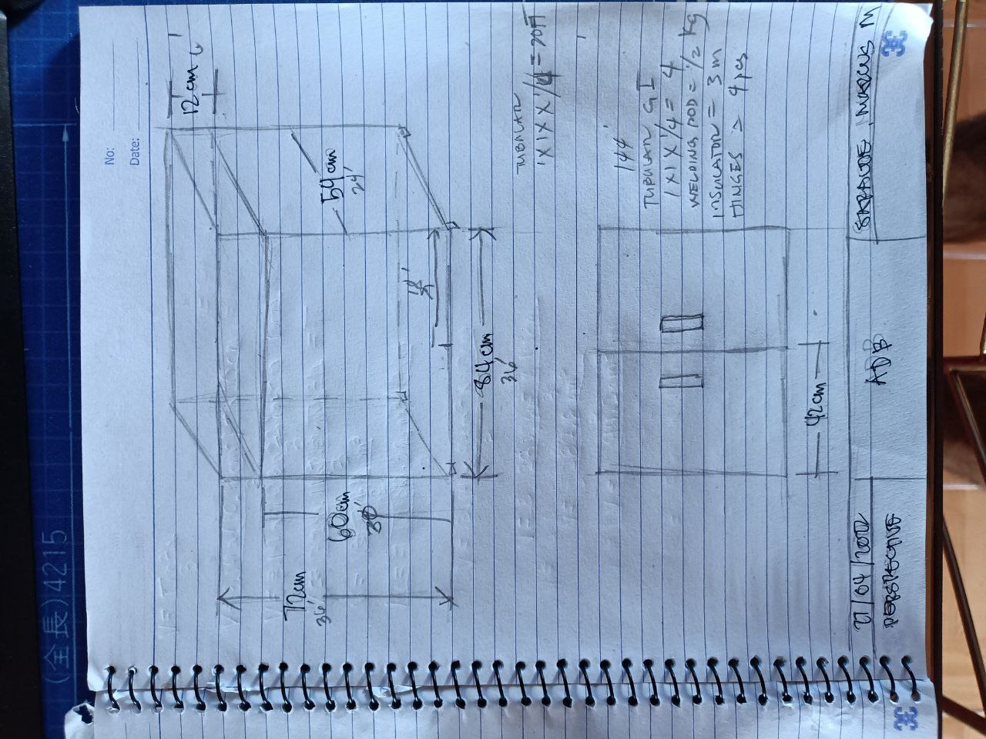

**Appendix 5: Survey and Four Point Likert Scale**

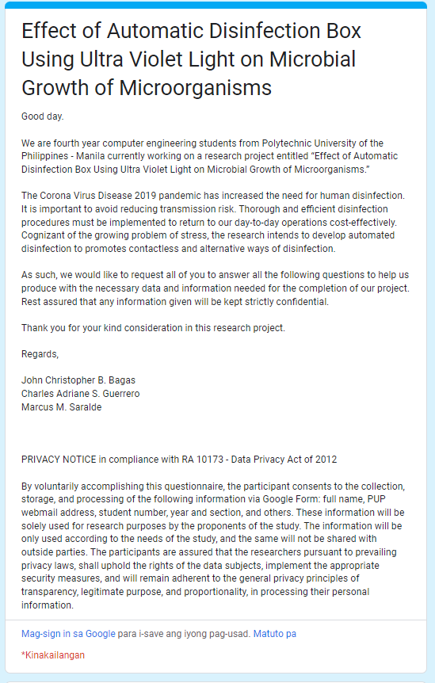

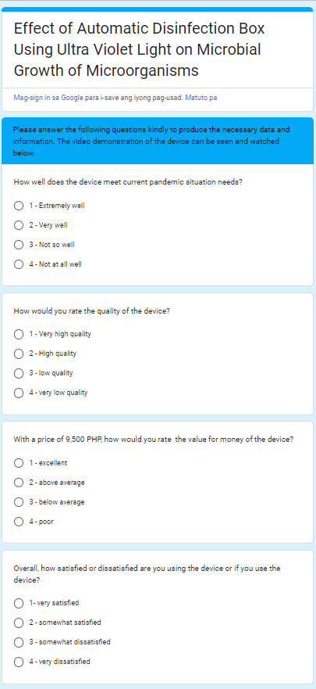

**Appendix 6: Source Code**

#include <Wire.h>

#include <SoftwareSerial.h>

#include <LiquidCrystal_I2C.h>

SoftwareSerial mySerial(9,10);

char msg;

char call;

LiquidCrystal_I2C lcd(0x27, 16, 2);

int ledPin = 3;

int buzzer = 2;

byte zero[] = {

B00000,

B00000,

B00000,

B00000,

B00000,

B00000,

B00000,

B00000

};

byte one[] = {

B10000,

B10000,

B10000,

B10000,

B10000,

B10000,

B10000,

B10000

};

byte two[] = {

B11000,

B11000,

B11000,

B11000,

B11000,

B11000,

B11000,

B11000

};

byte three[] = {

B11100,

B11100,

B11100,

B11100,

B11100,

B11100,

B11100,

B11100

};

byte four[] = {

B11110,

B11110,

B11110,

B11110,

B11110,

B11110,

B11110,

B11110

};

byte five[] = {

B11111,

B11111,

B11111,

B11111,

B11111,

B11111,

B11111,

B11111

};

void setup() {

digitalWrite(4, HIGH);

delay(1000);

digitalWrite(4, LOW);

delay(5000);

lcd.init();

lcd.backlight();

digitalWrite(ledPin, HIGH);

pinMode(ledPin, OUTPUT);

pinMode (buzzer, OUTPUT);

lcd.createChar(0, zero);

lcd.createChar(1, one);

lcd.createChar(2, two);

lcd.createChar(3, three);

lcd.createChar(4, four);

lcd.createChar(5, five);

mySerial.begin(9600);

Serial.begin(9600);

}

void loop() {

int pirState=digitalRead(6);

if (pirState == LOW) {

lcd.setCursor(0,0);

lcd.print("PUT OBJECT");

lcd.setCursor(0,1);

lcd.print("TO DISINFECT");

delay(500);

}

else if (pirState == HIGH) {

delay(3000);

lcd.clear();

lcd.setCursor(0,0);

lcd.print("DISINFECTING:");

delay(500);

digitalWrite(ledPin, LOW);

for(int i=0; i <= 100; i++) {

lcd.setCursor(0,1);

updateProgressBar(i, 100, 1);

delay(100);

}

delay(1000);

lcd.clear();

lcd.setCursor(0,0);

lcd.print("DONE!!!!");

digitalWrite(ledPin, HIGH);

digitalWrite(buzzer, HIGH);

delay(1000);

digitalWrite(buzzer, LOW);

delay(1000);

digitalWrite(buzzer, HIGH);

delay(1000);

digitalWrite(buzzer, LOW);

delay(1000);

digitalWrite(buzzer, HIGH);

delay(1000);

digitalWrite(buzzer, LOW);

SendMessage();

lcd.clear();

lcd.setCursor(0,0);

lcd.print("DISINFECTION");

lcd.setCursor(0,1);

lcd.print("COMPLETE");

delay(2000);

lcd.clear();

lcd.setCursor(0,0);

lcd.print("PLEASE REMOVE");

lcd.setCursor(0,1);

lcd.print("OBJECT NOW 5");

delay(1000);

lcd.setCursor(0,0);

lcd.print("PLEASE REMOVE");

lcd.setCursor(0,1);

lcd.print("OBJECT NOW 4");

delay(1000);

lcd.setCursor(0,0);

lcd.print("PLEASE REMOVE");

lcd.setCursor(0,1);

lcd.print("OBJECT NOW 3");

delay(1000);

lcd.setCursor(0,0);

lcd.print("PLEASE REMOVE");

lcd.setCursor(0,1);

lcd.print("OBJECT NOW 2");

delay(1000);

lcd.setCursor(0,0);

lcd.print("PLEASE REMOVE");

lcd.setCursor(0,1);

lcd.print("OBJECT NOW 1");

delay(1000);

lcd.setCursor(0,0);

lcd.print("PLEASE REMOVE");

lcd.setCursor(0,1);

lcd.print("OBJECT NOW 0");

delay(1000);

lcd.clear();

digitalWrite(pirState, LOW);

delay(5000);

}

}

void updateProgressBar(unsigned long count, unsigned long totalCount, int lineToPrintOn) {

double factor = totalCount/80.0;

int percent = (count+1)/factor;

int number = percent/5;

int remainder = percent%5;

if(number > 0) {

lcd.setCursor(number-1,lineToPrintOn);

lcd.write(5);

}

lcd.setCursor(number,lineToPrintOn);

lcd.write(remainder);

}

void SendMessage()

{

mySerial.println("AT+CMGF=1");

delay(1000);

mySerial.println("AT+CMGS=\"+639750710500\"\r");

delay(1000);

mySerial.println("DISINFECTED");

delay(100);

mySerial.println((char)26);

delay(1000);

**Appendix 7: Bill of Materials**

|  |  |  |
| --- | --- | --- |
| **Item** | **Quantity** | **Price** |
| Angle bar, cutting disk, welding rod, rubber wheels | 1 | 1690 |
| Galvanized Steel sheet .9 (4x8) | 1 | 1200 |
| Flat bar kilo | 5 | 200 |
| Insulation and stainless handles | 1 | 350 |
| Clear coat | 1 | 120 |
| Rugby, | 1 | 70 |
| Roller Catches | 4 | 205 |
| Labor assistance | 1 | 1000 |
| 1/4 thick glass | 1 | 200 |
| Steel Matting | 1 | 430 |
| Bosny Spray Paint White | 6 | 600 |
| Fyl201 | 1 | 1700 |
| Petri dish | 20 | 202 |
| Premixed nutrient agar | 1 | 257 |
| Cling wrap | 1 | 79 |
| Cotton swab | 1 | 54 |
| 16*2 LCD Display i2c | 1 | 146 |
| Arduino Uno r3 kit | 1 | 1200 |
| Sim900A | 1 | 270 |
| Total | | 9,973.00 |

**Appendix 8: Letter of Permission to**

**Rename Study**

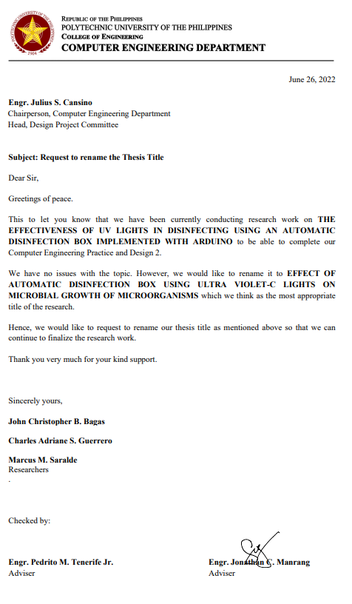

**Appendix 9: Certificate of Analysis**

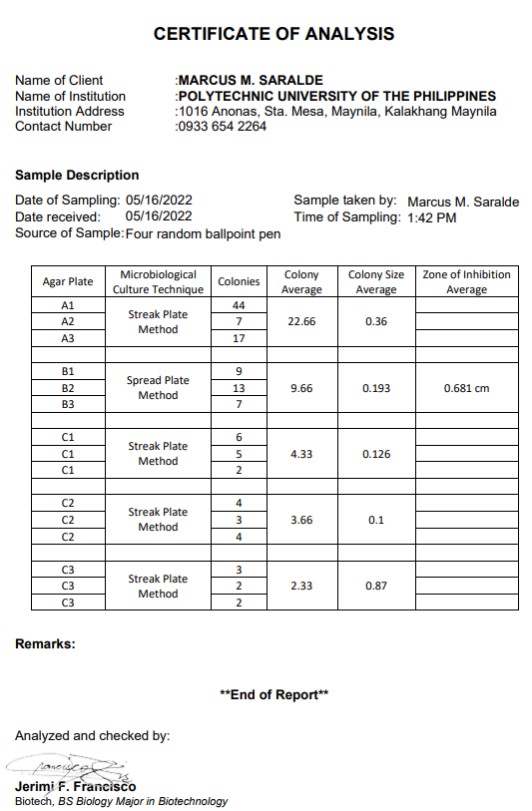

**Appendix 10: Certification of Statistical Treatment**

